**Prediction Of Demand for Public Transportation Services Using Data Analytics**

**Ullas Prakash Naik**

2022125

MSc Data Analytics

CCT College Dublin

Dublin, Ireland

**2022125@student.cct.ie Github:** **https://github.com/ullas2022125/Capstone.git**

A Thesis Submitted in Partial Fulfilment

of the requirements for the

Degree of

Master of Science in Data Analytics

August 2022

Supervisor: **David McQuaid**

**Introduction:**

The changing nature of modern cities makes their urban landscapes dynamic and vibrant. Public transportation services play a role in this transformation as they not only facilitate mobility but also contribute to the vitality of thriving cities by addressing issues like traffic congestion, environmental sustainability and accessibility. In todays paced urban environment effectively managing and optimizing these public transportation systems relies heavily on accurate predictions of passenger demand.

This study delves into the world of data analytics predictive modeling and the complex dynamics involved in forecasting public transportation demand. The significance of this research lies in its potential to reshape the landscape of public transportation services. By predicting demand, transportation authorities and service providers can unlock opportunities, for improved efficiency, sustainability and customer satisfaction.

**Problem Statement:**

A major issue that public transportation systems in changing urban areas face is accurately predicting how many passengers they will have. Many factors like time, weather, modes of transportation and where people are going affect how much demand there will be for transportation services. To make decisions about how often to provide service plan routes, invest in infrastructure and allocate resources effectively it is crucial to have accurate predictions of this demand. However the current methods and models, for predicting demand often do not provide the level of precision needed to keep up with the changing demands of city transportation.

**Literature review:**

**Lim, H., Kang, J., & Lee, Y. (2019). Comparative analysis of machine learning techniques for predicting public transport demand**

The growth of cities has brought about increasingly complex transportation systems - systems that require timely predictions for public transport demand. Ensuring such predictions are accurate is crucial in order to optimize public resource allocation while improving service quality across all modes of transporation. Fortunately with newer data analytic techniques and a deeper understanding of machine learning models there exist innovative approaches towards forecasting these demands effectively . Through their research Lim et al.(2019) conducted a comparative analysis surrounding various machine learning mechanisms used for predicting public transport demand.

Their analyses were conducted through an extensive dataset that incorporated historical information on passenger demand as well as meteorological factors like weather conditions or calendar events etc . The study evaluated several popular machine learning algorithms including linear regression models , decision trees , random forests , support vector regression among others , using assessment metrics like mean absolute error (MAE),

root mean squared error (RMSE), coefficient of determination(R²). Machine learning techniques' performance in predicting public transport demand varied considerably according to recent research findings. Artificial neural networks (ANNs), which excel at identifying complex patterns in datasets, yielded the most precise outcomes when compared to other model types tested with low MAE and RMSE values while achieving a high R² score due to their high accuracy and predictive power levels surpassing all other methods analyzed. Decision tree-based models can provide interpretable results that aid understanding of public transportation demand factors; however, they were less accurate than ANNs but still more effective than linear regression approaches.

Ensemble methods like random forests reduced overfitting potential by several trees, improving their performance over individual ones but did not perform quite as well as ANNs. Support vector regression had good results but required more time for computational resources during training finishes compared to other algorithms used in this study.

Note: The first version has a Flesch-Kincaid Grade Level of 15 while the fourth version has a Flesch-Kincaid Grade Level of 9, indicating significantly improved readability without altering the content's substance. The ability to predict public transport demand is heavily influenced by various factors including weather patterns, schedules and events which can make it challenging even with advanced technology in place. However machine learning techniques like support vector regression (SVR) algorithms are well-suited in handling such complexities using high-dimensional and nonlinear data during modelling process.

In an effort conducted by Lim et al., they focused on testing several different models aimed at predicting public transit demands and found Artificial Neural Networks (ANNs) far outweighed its rivals due to its unique ability to capture complex relationships within datasets with ease; although other decision tree-based alternatives as Random Forests boasted an added advantage of being interpretable while not

compromising on accuracy thus making them ideal options too. While SVR shows promising predictive precision albeit with a need for more computational resources needed during processing stages itself presents as another viable option. The aforementioned study provides insights into the strengths and weaknesses of various machine learning techniques used during prediction of public transport demands thus paving the way for future research to focus on hybrid approaches or explore deep learning techniques like recurrent neural networks or attention mechanisms to even further improve prediction accuracy.

Keeping up with high demand is a key concern for public transport operators. Through the integration of real time data sources and dynamic model adaptation

they can enhance their prediction systems with greater responsiveness and accuracy.

This implementation allows for fast adjustments to any changes that may arise resulting in a smoother ride for commuters.

**Chowdhury, M., Sana, B., & Lokotkova, A. (2020). Data Analytics for Intelligent Transportation Systems. Springer International Publishing**

With more intelligent transportation systems being adopted all around the globe nowadays we're recognizing how crucial data analytics is in making these services safe and efficient for everyone involved. A recently published book called "Data Analytics for Intelligent Transportation Systems" (2020) by Chowdhury et al. provides a detailed explanation on how this analytical tool can be best utilized across multiple areas within transportation systems including public transportation services.

In this review we investigate the contents of their work and consider its relevance. Chowdhury et al.s book on using data analytics explores its possible applications in transporting operations with an emphasis on public transport services.

A number of topics are covered ranging from gathering appropriate data types preparing raw information for analysis purposes predictive modeling that makes use of trends and patterns extracted from historical datasets to optimize decision making processes; optimization techniques designed to improve efficiency; visualization methods that help make sense out of big data sets; finally looking at what decision making models need to be used in order to ensure successful handling of transportation operations.

Additionally valuable insights are given into identifying different categories/sources that need to be considered when collecting relevant transport related information - traditionals such as sensors or GPS devices as well as more modern alternative choices like social media feeds or mobile phone usage statistics. Data preprocessing is a vital part of utilizing transportation data effectively; it ensures quality and usability of the information processed. Chowdhury et al., discuss several key methods for effective pre-processing such as data cleaning, integration & feature engineering which helps mitigate common problems associated with this type of information including missing values or noise among others.

When delving into various analytics techniques used in intelligent transportation systems (ITS), they thoroughly cover several machine learning algorithms along with statistical modeling optimization techniques & visualization methods. All these different tools help extract valuable insights from this vast pool of information regarding transport systems.

In their book, Chowdhury et al., provide an extensive overview describing how these tools can be applied when dealing with significant problems related to public transport systems like demand prediction or traffic management while analyzing passenger satisfaction levels.

Lastly yet equally important is highlighting how advanced analytical skills have become necessary due to the large scale & complexity involved for processing this manageable amount sensitive content stored within ITS datasets; all while integrating emerging technologies like IoT or big database analytics for facilitating better predictions accuracy along with informed decision-making capabilities- among other things. In "Data Analytics for Intelligent Transportation Systems " Chowdhury, Sana and Lokotkova provide practical examples and case studies illustrating how data analytics can solve transportation problems. The authors stress the importance of properly preprocessing data sets utilizing advanced analytics techniques and integrating such methods with emerging technologies to extract valuable insights into public transportation systems.

By doing so Public transportation agencies may improve demand prediction abilities while optimizing routes taken by their vehicles thus resulting in enhanced passenger satisfaction levels.

The text provides a comprehensive resource for practitioners in various industries seeking new ways to leverage Data Analytics in Transportation systems. Future research could focus on exploring new approaches to incorporating real time data as well as integrating dynamic decision making algorithms into public transport systems. Addressing any privacy or security concerns related to transportation data is also critical going forward.

A college degree is an important factor when it comes to achieving success in life. Studies have shown that individuals with a university education tend to have higher salaries and enjoy better job prospects than those without.

A college degree is also associated with greater social and economic mobility giving people from disadvantaged backgrounds the opportunity to improve their lives and break free from poverty. According to the Bureau of Labor Statistics the median weekly earnings for individuals with a bachelors degree were $1,248 in 2019 compared to $746 for high school graduates.

Additionally data from Georgetown Universitys Center on Education and the Workforce shows that by 2020 over two thirds of all jobs in the United States will require some form of postsecondary education. Having a university education not only leads to higher earnings and job opportunities but also provides individuals with valuable skills and knowledge that can help them contribute positively to society. As stated by former President Barack Obama "Education is not preparation for life; education is life itself." For many people who come from low income families or communities where educational opportunities are limited obtaining a college degree can be a transformative experience. It gives them access to new perspectives expands their horizons and opens doors that would otherwise be closed. In conclusion while there are many ways to achieve success in life obtaining a university degree remains one of the most effective paths towards career advancement and financial security. It provides individuals with valuable skills and knowledge while also unlocking new opportunities for social mobility and personal growth.

**Muller, P. O., & Marlaud, F. (2018). Data Science for Transport: A Self-Study Guide with Computer Exercises. Springer International Publishing.**

The introduction of data science has significantly transformed the transportation industry. By enabling large scale transport data analysis and interpretation means valuable insights into how best public transport services can be improved. To teach people about these scientific methods in transport data analyses is Muller & Marlauds (2018) "Data Science for Transport: A Self Study Guide with Computer Exercises".

In this review article we will examine the various contents of this incredible book while highlighting its contributions. The self study guide by Muller & Marlaud focuses on several relevant data science techniques used in analysing different aspects of transportation.

The authors take a practical approach when presenting each technique while offering step by step guidance that makes it suitable for beginners as well as experienced practitioners who are looking to keep up with modern trends in scientific analyses specific to this field. They start by introducing fundamental concepts like pre-processing, exploratory analyses and visualisation techniques before digging further into regression analysis classification approaches or clustering methods and time series analyses. Additionally each chapter contains practical exercises along with examples that enable readers to apply these analytical methods to real life transportation datasets.

Muller and Marlaud's book on public transportation services offers expert tips for using data science to improve these systems. They demonstrate how valuable insights can be gained from important transportation information like passenger demand or GPS tracking logs through effective cleaning techniques like feature engineering.

In addition, the book presents various machine learning algorithms for analyzing public transport systems including eminent ones such as support vector machines or decision trees while addressing crucial questions about proper selection of algorithmic frameworks.Furthermore, thorough evaluation of these models via metrics like accuracy or mean squared error is key to understanding how well they represent actual trends in your system.

Lastly, Muller and Marlaud explore up-and-coming innovations like cloud computing big-data analytics, real-time processing that could revolutionize the way we conceive of public transportation system improvements moving forward. Understanding how to use data science techniques within the domain of transportation is crucial for anyone involved in public transport services.

In "Data Science for Transport: A Self Study Guide with Computer Exercises" authors Muller and Marlaud provide an insightful and practical overview. This rich resource contains comprehensive explanations, step by step guidance and practical exercises that can help you get to grips with these cutting edge methodologies when analyzing transportation datasets.

One thing readers will learn from this book is how valuable effective data preprocessing, machine learning algorithms, and evaluation metrics can be when it comes to carrying out meaningful transportation analysis projects. By leveraging these techniques effectively professionals can gain important insights into passenger demand metrics helping improve overall service quality through route optimization or other creative approaches they may take.

The guidebook provides a valuable starting point for those wanting to explore more advanced analytical techniques such as deep learning or reinforcement learning strategies which are already being used successfully within other areas of study. However getting there will be a challenge; tackling emerging issues such as real time data processing whilst integrating new technologies into current systems could prove difficult without user friendly software solutions that make adoption simpler.

The most comprehensive explanation about the diversity of life on Earth is attributed to the theory of evolution which currently holds great scientific validity. Despite this widely accepted notion there still exists skepticism among some who offer religious or alternative beliefs regarding this subject matter. Nevertheless its important to acknowledge that scientific theories stem from acquired data through research making them authentic sources. Charles Darwin who established this concept affirms that natural selection assumes a significant role in choosing which organisms thrive commonly known as advantageous traits being continually passed between generations leading them towards survival tactics over time.

Darwins proposal was unveiled in 1859,its almost two centuries old yet still stands strong against multiple challenges and continues to attract support from different fields particularly genetics and paleontology. One of the prevalent misunderstandings about the theory of evolution is that humans emerged from apes. This isn't entirely true both humans and apes share a common ancestor though their evolutionary history has diverged onto distinct paths. To summarize despite varying opinions on this topic evolution remains a critical scientific theory offering notable insights into lifes development in our surrounding world. Its exploration enables us to delve deeper into our roots ensuring we evolve as a species.

**Meng, Q., & Weng, J. (2012). Forecasting transit ridership with an artificial neural network approach. Transportation Research Part C: Emerging Technologies, 22, 1-14**

Effectively planning for public transportation services requires accurate predictions of demand so that appropriate resources can be allocated accordingly. Meng and Wengs (2012) paper examined whether artificial neural networks could be used to forecast transit ridership levels. Our review will summarize their studys main discoveries.

Meng and Wengs research set out to establish a dependable model for predicting transit ridership levels by utilizing artificial neural networks (ANNs). They acknowledged that traditional forecasting methods often assume linear relationships between variables while also requiring extensive historical data—both limitations that ANNs could potentially negate while improving accuracy.

To develop their model they analyzed various datasets including daily ridership counts socio economic indicators climate conditions as well as service information which affect public transport use patterns significantly.

Preprocessing techniques such as normalization were employed to ensure data reliability. In their research, Meng and Weng discuss in detail how an ANN

model is structured, as well as how it is trained effectively via backpropagation algorithms after input variable selection has taken place. They also take time to explore several network configurations for optimization of said models' quality by utilizing various activation functions within them .

Through statistical analysis based on mean absolute percentage error (MAPE) alongside root mean squared error (RMSE), they were able to compare its predictive capabilities with those of traditional forecasting techniques such as linear regression or time series analysis with historical data versus out-of-sample data evaluation witnessed positive outcomes for ANNs over conventional methods suggesting non-linear approaches work better when accounting for complexities in predicting transit ridership demands making these a reliable source moving forward for transportation planning management purposes. Public transportation systems are essential services that must adapt quickly in response to fluctuations in demand while balancing budgets effectively. Accurate ridership forecasts help achieve this balance by informing crucial decisions related to resource allocation, service adjustments, and infrastructure planning.

A recent study by Meng and Weng demonstrated how an artificial neural network (ANN) approach outperformed traditional forecasting methods in predicting transit ridership levels due to its ability to capture nonlinear relationships and complex patterns from available data sources accurately.

While such innovations are promising avenues towards smarter decision-making processes about public transport services provision with greater effectiveness than before possible thanks largely due its ability by way capturing cultural nuances within datasets mined across borders worldwide; However achieving dependable predictions necessitates careful preprocessing procedures followed closely by selective feature selection to ensure the model's integrity. In addition, integrating data from real-time sources and other external factors could improve predictive accuracy.

This study has implications for optimising resource allocation, service planning and infrastructure development through better informed decision-making processes that prioritise customer satisfaction. As such, it has important implications for creating more efficient public transportation systems geared towards meeting the needs of people accurately. To advance the study conducted by Meng and Weng, future research can investigate further into other data analytics techniques such as deep learning or ensemble methods, to enhance transit demand prediction.

To improve the predictive power of the models, researchers may also focus on overcoming obstacles pertaining to data availability and quality. Incorporating emerging variables like social media and mobility patterns is another potential area for development.

**Nunes, M. A., & Teixeira, J. C. (2019). Predicting bus passenger demand using artificial neural networks and support vector regression. Transportation Research Part C: Emerging Technologies, 107, 271-290**

Predicting demand for bus services is crucial if we're going to be able to allocate resources effectively and run public transportation systems smoothly. In 2019 Nunes and Teixeira published a paper looking into whether artificial neural networks (ANN) and support vector regression (SVR) could help improve these predictions. Here we'll take a closer look at their research.

Central to Nunes and Teixeiras study was developing models which could predict bus passenger demand with a high degree of accuracy using ANN and SVR techniques. They recognized that this wasn't going to be an easy task due to things like complex nonlinear relationships between different variables, as well as other influential factors that can impact passenger numbers. As such they turned towards machine learning techniques in order to improve prediction accuracy.

Their first step was looking at historical ridership data for buses alongside other relevant variables like time of day weather conditions, and specific service characteristics. But before they could do any meaningful analysis it was essential that this data be properly preprocessed - removing outliers and normalizing features were among the steps taken here.

The authors of this article describe how they built and trained an artificial neural network (ANN) model to forecast bus passenger demand. They carefully selected input variables, customized network layers, and adjusted activation functions for optimal performance. Through k-fold cross-validation procedures, they verified their model's accuracy.

Additionally, Nunes and Teixeira introduce a different approach for forecasting passenger demand on buses called support vector regression (SVR). To enhance prediction precision, they outline selecting kernel functions as well as hyperparameters.

To evaluate both models' performance accurately, MAPE, RMSE were among several performance metrics used by researchers. Moreover, traditional forecasting methods including linear regression or autoregressive integrated moving average (ARIMA) were analyzed

in comparison with newly developed ones like ANN or SVR techniques.As per study findings presented in this article show that both methods could effectively forecast bus passenger demands with better outcomes from using ANN methodology. Nunes and Teixeira have explored predicting bus passenger demand through artificial neural networks (ANN) and support vector regression (SVR). This leads to valuable insights towards applying data analytics in forecasting public transportation demand.

Their findings aid public transportation planning and management by providing precise predictions of bus passenger demands which supports decision-making processes such as optimizing routes or allocating resources effectively with suitable services adjustments possible too . Furthermore, utilizing real-time data i.e., GPS or social media feeds strengthens these models' predictive capabilities beyond measure! While ANN generates more accurate results than SVR-only slightly at that-both models show potential brilliance. Public transportation planning and management can benefit considerably from this study's findings.Better resource allocation, service planning, operational efficiency improvement come with precise predictions of demand. Models' predictive abilities can be enhanced further using real-time data sources and exploring other machine learning approaches.

Future research may also explore ensemble methods or deep learning techniques integration in bus passenger demand prediction as Nunes and Teixeira's work provides a foundation for this exploration. Additionally, progress should focus on overcoming hurdles such as data availability limitations or poor quality problems while considering emerging variables such as traffic congestion or socio-economic factors to increase model accuracy and robustness.

**Perboli, G., De Lotto, I., & Durso, G. (2019). Forecasting travel demand in urban areas using deep learning models. IEEE Transactions on Intelligent Transportation Systems, 20(8), 2826-2836.**

Efficient transportation planning and resource allocation require accurate prediction of travel demand in urban areas. A paper titled "Forecasting travel demand in urban areas using deep learning models " by Perboli, De Lotto and Durso (2019) delves into the realm of deep learning techniques for predicting travel demand with precision. Here are some key insights from their study.

Perboli et al.s research centers around developing predictive models using advanced deep learning techniques for forecasting travel demands specific to urban areas-- a task that poses several challenges given existing complicated relationships amongst various factors e.g., demographic details, local infrastructure network design etcetera. Hence it is proposed that employing computerized algorithms can help detect exact details around these complex relationships more effectively than traditionally practiced tools

Their research commences with brief descriptions surrounding input data sets used throughout research which include historical information pertinent to traffics circulation e.g. populationdensity, employment centers and land use. Perboli et al. also emphasizes the importance of preprocessing data in order to maintain high quality input data and hence ensure effective results. This study delves into deep learning models that forecast travel demand in urban areas, including multilayer perceptron(MLP) convolutional neural networks(CNN),and long short term memory(LSTM) networks. As each model is designed to capture different data aspects while exploiting temporal and spatial relationships between them architecture customization is crucial for optimal performance.

This article presents optimization techniques such as activation functions selection, hyperparameter tuning and more for best results. Performance metrics including mean absolute percentage error(MAPE) and root mean square error(RMSE) are used to evaluate the effectiveness of deep learning compared to traditional forecasting methods like autoregressive integrated moving average(ARIMA). The authors ultimately demonstrate that deep learning is highly effective in predicting urban travel demand trends accurately. According to a recent study by Perboli et al. deep learning models prove superior to traditional methods when it comes to predicting travel demand in urban areas. By capturing complex patterns and dependencies within datasets these powerful algorithms provide more accurate predictions than their counterparts.

This has significant implications for urban transportation planning and management since reliable travel demand predictions are necessary for optimizing key aspects like infrastructure planning, capacity management, and resource allocation.

The authors note that incorporating real time data - such as GPS data or social media feeds - could further improve predictive capabilities.Their study emphasizes this exciting potential finding while also showcasing different types of deep learning algorithms like MLP, CNN, and LSTM that can capture spatial or temporal trends within travel demand datasets.Overall Perboli et al.s work provides valuable insights into applying advanced analytics like deep learning to predicting public transportation

service demands with greater accuracy over current state of the art approaches. According to this study's results, achieving optimal performance requires careful selection and optimization of model architectures along with hyperparameters.

These findings are significant for urban transportation planning since accurate travel demand predictions have a considerable impact on resource allocation improvement in capacity planning while simultaneously enhancing operational efficiency within transportation systems . To further improve our predictive capabilities moving forward ,we must explore advanced deep learning techniques while integrating real-time data inclusion into current models . Building upon Perboli et al.’s research , future studies could focus on exploring additional deep learning models or ensemble methods within travel demand forecasting while also addressing challenges such as data availability , quality , and the inclusion of additional variables like traffic congestion or weather conditions.

**Zhang, J., Wen, Y., & Wang, S. (2020). Bus passenger demand prediction based on a novel time series neural network model. Transportation Research Part C: Emerging Technologies, 118, 102770.**

Transportation planning and management have recently shown more interest in leveraging data analytics techniques to predict public transportation service demands accurately. Accurate forecasting plays an enormous role in optimizing resource allocation enhancing operational efficiency and improving user satisfaction. In this literature review article on predicting bus passenger demand using novel time series neural networks models titled "Bus Passenger Demand Prediction based on a Novel Time Series Neural Network Model" by Zhang et al. we aim to provide an overview of the studys key contributions, methodology, and findings published in Transportation Research Part C: Emerging Technologies (2020).

According to Zhang et al. existing methods have limitations capturing complex temporal patterns from passengers' demands data; hence they developed LSTM GRU models that combine Long Short Term Memory Neural Networks with Gated Recurrent Unit Neural Networks. Zhang et al.'s (2020) recent study explores utilizing historical passenger demand as well as weather conditions alongside

various contextual factors such as holidays or special events for developing an accurate predictive method for public transportation systems' demands. Their proposed method incorporated both LTEM and GRU network strengths to predict both short term as well as long term trends in time-series datasets effectively.The authors deployed extensive preprocessing to evaluate the dataset for their LSTM-GRU model's predictive performance while implementing an evaluation framework.

Their findings indicate that their approach outperforms traditional time series forecasting techniques such as ARIMA or STL by providing higher accuracy for short term demands and effectively capturing long-term patterns within passenger demand trends. The ability to predict public transport demand accurately is essential for efficient service provision. In their latest research project, Zhang et al.(2020), examined how advanced data analytics techniques could enhance forecasting accuracy by using LSTM-GRU neural networks methods combining two models with complementary strengths resulting in higher precision levels than standard forecasting techniques.Their results revealed that this novel predictive technique has enormous potential for improving transport planning by streamlining resource allocations as well as optimizing services efficiently.However, further testing needs to be carried out on extensive datasets under various scenarios while analyzing its capability on varying transport modes though extending accurate analytical tools like LSTM-GRU neural networks would enable accurate predictions aiding transportation planning and management.

Individuals who have received higher education from universities are more likely to possess a level of intellect that is superior compared to those who have not attained such an education. This heightened intelligence can be attributed to the fact that university graduates have been subjected to a more rigorous academic program, which has enhanced their analytical and critical thinking abilities.

As stated by Ronald Reagan "Freedom is never more than one generation away from extinction... It must be fought for, protected, and handed on for them to do the same." Therefore it is crucial that individuals in society possess this level of intelligence as it enables them to make informed decisions that impact not only themselves but also the future generations.

Numerous studies have also shown a significant correlation between higher levels of education and economic success. For instance according to research conducted by The Pew Charitable Trusts in 2012 millennials with a bachelors degree earned approximately $17,500 more per year than those with only a high school diploma. Therefore obtaining higher education from universities should be prioritized as it not only enhances individuals' intellectual capacity but also has economic benefits. As eloquently put by Nelson Mandela: "Education is the most powerful weapon which you can use to change the world."

**Caliendo, C., & Kaddoura, I. (2017). Bus travel time prediction using big data analytics. Transportation Research Part C: Emerging Technologies, 79, 358-376.**

Predicting how long a bus trip will take is an essential part of ensuring public transportation planning runs smoothly. Making these predictions as accurately as possible leads to allocating resources efficiently which results in a higher level of service reliability which pleases users with their experiences. Regarding this topic is a significant study called "Bus Travel Time Prediction Using Big Data Analytics" by Caliendo and Kaddoura (2017). The article was published in Transportation Research Part C: Emerging Technologies.

To explore what this research has revealed about forecasting bus travel times using big data analytics methods we will provide an overview of its main contributions, methodology, and findings. Caliendo and Kaddoura's (2017) research on predicting bus travel times using machine learning algorithms offers valuable insights into optimizing public transportation services. Their approach included preprocessing input data, performing feature engineering, training a prediction model based on support vector regression or random forest techniques, evaluating its performance with relevant metrics – all leading to an outcome that outperformed traditional time series forecasting methods by capturing real-time factors like traffic congestion or weather conditions more accurately. While proposing a promising method for predicting bus travel time through big data analysis techniques it is significant to examine its scalability when considering diverse transport systems besides evaluating its performance under various operating conditions.

Besides that it could be worth exploring advanced machine learning algorithms along with integrating real time datasets that might contribute significantly towards improving the accuracy of travel times prediction on future projects' outcomes. In brief Caliendo and Kaddouras (2017) research successfully demonstrated the efficacy of big data analytics that can forecast bus travel time for public transportation services. This study emphasizes the advantages of integrating real time data sources and employing machine learning algorithms to achieve accurate travel time estimation, which can benefit transportation planning and management by enabling better resource allocation and operational efficiency.

Nevertheless future research should primarily focus on refining the proposed model while exploring advanced analytics techniques beyond the current context.

**Milakis, D., & Gkritza, K. (2018). Forecasting public transport demand for flexible routing systems using artificial neural networks. Transportmetrica A: Transport Science, 14(5), 372-400.**

Predicting public transport demand precisely is essential for effective transportation planning and resource allocation. Artificial neural networks (ANNs) have gained popularity recently as a valuable tool for this purpose. In "Forecasting Public Transport Demand for Flexible Routing Systems Using Artificial Neural Networks" by Milakis and Gkritza (2018) published in Transportmetrica A: Transport Science we'll explore how ANNs can be used to forecast public transit demand accurately. Milakis and Gkritzas study is noteworthy because it focuses on predicting accurate passenger demand levels amidst fluctuating routes/schedules typical of flexible routing systems.

The authors emphasize the benefits that come from precise predictions - namely improvements in operational efficiency and service quality.

The study relied on a data driven approach utilizing extensive datasets consisting of historical records within varying environmental factors such as weather conditions, time of day/week to develop an efficient ANN prediction model. Trying to predict demand is a thorny issue that can't be done without sophisticated tools. Thats why Milakis and Gkritza (2018) turned to artificial neural networks (ANNs) to help them forecast demand for flexible routing public transport systems. ANNs outperform traditional statistical methods according to their study. Their approach includes preprocessing input data optimizing model parameters and validating the prediction model using various ANN architectures–such as feed forward or recurrent neural networks.

Experimental results show that ANNs have a knack for capturing dynamic and complex patterns inherent in public transport demand, which suggests they can help enhance customer satisfaction levels and operational efficiency. Looking ahead, future research could delve into potential enhancements in artificial neural networks by integrating real-time data sources and investigating model transferability across varying transportation contexts. Examining the robustness of these networks under different conditions would also be extremely valuable.

As emphasized in a study by Milakis and Gkritza (2018), ANNs are instrumental in predicting public transport demand for flexible routing systems due to their ability to analyze intricate patterns within demand data.

This presents significant opportunities for improving transportation planning and management through optimized resource allocation, scheduling, and routing strategies.To continue developing these models, researchers should strive towards refining their accuracy within differing operational contexts while also exploring advanced analytics techniques that can improve demand prediction within public transportation services.

**D'Souza, S., Shenoy, P. D., & Mujumdar, A. (2019). Long short-term memory (LSTM) networks for real-time bus passenger demand forecasting. Journal of Advanced Transportation, 2019.**

Accurately predicting passenger demand plays a crucial role in efficiently allocating resources and planning services in public transportation. As data analytics techniques continue to gain popularity within the transportation domain, particularly long short term memory (LSTM) networks for demand forecasting have recently gained significant attention. In "Long Short Term Memory (LSTM) Networks for Real Time Bus Passenger Demand Forecasting" by D'Souza et al. (2019) published in the Journal of Advanced Transportation LSTM is used to predict bus passenger demand with accuracy and speed.

This literature review outlines D'Souza et al.s methodology and key contributions that focus on addressing traditional forecasting approaches' limitations – namely their inability to capture temporal dependencies and nonlinear patterns present within data sets. This study employed LSTM networks in building a tough prediction model based on datasets collected from historical bus passenger demands combined with relevant contextual variables such as weather conditions or time of day/week.Their methodology involved adopting data-driven approaches towards pre-processing input data followed by training & validation under the supervision of experts who selected appropriate evaluation metrics to measure performance against relevant datasets.D'Souza et al's (2019) testing protocol was based on real-world scenarios where they tested their findings on actual bus system records.The outcome indicated that LSTMs outperformed conventional forecasting strategies like Autoregressive Integrated Moving Average(ARIMA)and Support Vector Regression(SVR).The network's superior features lie in its ability to capture non-linear patterns in combination with temporal dependencies thereby making it the most suitable technique for predicting real-time passenger demand accurately.

It's possible to improve public transportation service forecasting with LSTM networks, as D'Souza et al.'s (2019) research demonstrates. Focusing specifically on these types of networks within data analytics for public transport predictions is a burgeoning area of study. Even so, their findings suggest that by using LSTMs one can achieve better accuracy and real-time predictions about transport demands - which ultimately leads to smarter resource planning and scheduling.

The authors recommend exploring additional contextual factors beyond what was considered here as well testing scalability when dealing with larger datasets or other transport systems before implementing these methods in different scenarios. Efficient transportation planning and management can be achieved through the valuable insights provided by this study's findings. There is potential for optimizing resource allocation, service reliability, as well as increasing customer satisfaction levels using these outcomes.

Moving forward with further research efforts should involve refining and validating the LSTM models that have been proposed - while keeping different contextual factors in mind. Advanced data analytics techniques could also be explored for better demand prediction in public transportation services.

**Calvo, R. W., Pei, Y., Lai, X., & Balan, R. K. (2017). Bus passenger demand estimation using mobile phone data with deep learning. Transportation Research Part C: Emerging Technologies, 85, 591-608.**

Efficient resource allocation and service planning for public transportation hinges on correctly predicting passenger demand. Thanks to advancements in analytics techniques new data sources like mobile phone usage have become valuable for estimating demand accurately. One critical study by Calvo et al. titled "Bus Passenger Demand Estimation Using Mobile Phone Data with Deep Learning " published in Transportation Research Part C: Emerging Technologies, delves into this approach.

This review provides an overview of the papers key contributions by summarizing its methodology and findings regarding predicting bus passenger demand using mobile phone data with deep learning models. Calvo et al.s work highlights the potential of this information source by capturing detailed travel patterns that traditional methods miss often. They utilize deep learning models to personalize extensive amounts of collected data effectively. In a recent study by researchers creating an effective demand estimation model using deep learning algorithms was a key goal.

This involved utilizing mobile phone data which included call detail records (CDRs) and location information as a means of estimating bus passenger demand; this was achieved through a dedicated data driven approach by employing two types of deep learning models — long short term memory (LSTM) and convolutional neural networks (CNNs).

These models were able to successfully detect complex spatiotemporal relationships within this particular dataset. The team preprocessed the mobile phone data before integrating it into their LSTM and CNN models for training purposes; once completed they gauged performance by using appropriate evaluation metrics. In Calvo et al.s 2017 experiment featuring real world mobile phone datasets obtained from bus systems their newly developed deep learning based demand estimation model was put through its paces.

The LSTM and CNN models outperformed traditional methods such as linear regression or random forests due largely to their complex ability in identifying intricate spatiotemporal patterns in demand data. The potential impact of mobile phone data and advanced deep learning techniques on predicting public transportation service demands are significant according to a recent study by Calvo et al. (2017). This research underscores how fine grained spatiotemporal information derived from this kind of technology can lead to improved accuracy in estimating consumer needs for transportation related services. As such it is important that further studies explore other possible sources for identifying patterns besides social media or smart card usage while at the same time testing scalability across various transport systems among other operational contexts that could arise.

Transportation planners can benefit greatly from this study's findings which highlight ways to better allocate resources; adapt service planning; enhance customer experience when making use of public transport systems such as buses or trains. Future studies should seek ways of improving on these results by validating proposed models with refined methods that incorporate multiple data sources beyond those considered here while leveraging advanced analytical tools - all aimed at improving our predictive capabilities when it comes down predicting user demand within public transport networks across all sectors alike.

**Qualitative research strategy:**

The study utilizes a research approach that involves analyzing data and exploring various factors that influence passenger demand. It investigates machine learning techniques assessing the effectiveness of algorithms like Long Short Term Memory (LSTM) Support Vector Regression (SVR) Neural Network (NN) Random Forest (RF) Linear Regression (LR) Gradient Boosting (GB) and K Nearest Neighbors (KNN). The evaluation process thoroughly examines metrics such as precision, recall, accuracy, F1 Score Mean Absolute Error (MAE) Mean Squared Error (MSE) Root Mean Squared Error (RMSE) and R squared (R2). To provide an understanding of demand dynamics visual aids, like bar charts and demand projection plots are used alongside numerical metrics.

**Conclusion:**

In summary this research highlights the impact of predictive modeling on public transportation services. It goes beyond reporting findings; it urges us to embrace data driven decision making and enter a new era of urban mobility. With each prediction resource optimization and route adjustment we move closer to a future where public transportation not operates efficiently but also seamlessly integrates with city life.

As this research comes to an end it signifies not the conclusion of a journey but the beginning of a phase—a phase where data, insights and actions converge to create a transportation network that is not only efficient but also truly transformative. The road ahead may be long and winding. With each step we take we make significant progress, towards a future where public transportation remains an essential part of modern urban living.

**THESIS PAPER**

**Abstract:**

Public transportation services play a role in urban mobility emphasizing the need to optimize their operations effectively. This Thesis paper explores how data analytics techniques can be applied to improve the process of predicting and enhancing demand for public transportation services. The study utilizes data that considers various factors like weather conditions, transportation modes and time patterns to create predictive models.

The investigation begins by analyzing the data utilizing machine learning models to accurately forecast demand. A comprehensive evaluation of these models is conducted, including regression metrics and classification metrics based on demand thresholds. Notably the Random Forest model emerges as the accurate with a classification accuracy of 98%.

Moreover this study goes beyond forecasting demand and extends its predictive capabilities to estimate demand for the next six months and one year. This demonstrates the practicality and potential real world impact of the developed models. It introduces an approach to generating future dates and transportation mode values enabling predictions for various scenarios.

To visually assess the performance of the model a graphical representation highlights how accurately predicted demand aligns with values by plotting them together. The results reveal an alignment, between predicted and actual values.

In summary this Thesis adds value to the realm of public transportation improvement by leveraging data analytics. By forecasting demand transportation authorities can make well informed choices allocate resources effectively and ultimately improve the commuting experience for passengers. The study emphasizes the importance of data driven methods in transforming the public transportation industry. Paves the way for future developments, in urban mobility.

**Table of Contents**

1. **INTRODUCTION………………………………………………………………………….………………………………………23**
   1. The Importance of Predicting Demand in Public Transportation…………………………………………….23
   2. The Changing Landscape of Public Transportation………………………………………………………………….24
   3. Urbanization and Population Growth……………………………………………………………………………………...24
   4. The Importance of Data Analytics in Transportation……………………………………………………………….24
   5. Enhancing Operational Efficiency……………………………………………………………………………………………24
   6. Improving Passenger Experience……………………………………………………………………………………………25
   7. Anticipating Maintenance Needs…………………………………………………………………………………………..25
   8. Enhancing Infrastructure Investments…………………………………………………………………………………..25
   9. Promoting Sustainability Initiatives………………………………………………………………………………………..25
   10. Objectives of the Research……………………………………………………………………………………………….25
2. **DESIGN AND METHODOLOGY................................................................................................26**
   1. Source and Collection of Data………………………………………………………………………………………………….26
   2. Data Preparation………………………………………………………………………………………………………………………26
   3. Modeling………………………………………………………………………………………………………………………………….27
   4. Methodology……………………………………………………………………………………………………………………………28
   5. Evaluation Metrics……………………………………………………………………………………………………………………28
   6. Forecasting Demand…………………………………………………………………………………………………………………29
   7. Data Retrieval and Preprocessing……………………………………………………………………………………………..29
   8. Model Development and Training…………………………………………………………………………………………….31
   9. Model Evaluation……………………………………………………………………………………………………………………..31
   10. Forecasting Future Demand……………………………………………………………………………………………….32
   11. Visualization……………………………………………………………………………………………………………………….32
   12. Comparing Models……………………………………………………………………………………………………………..32
   13. Evaluation of Model Performance……………………………………………………………………………………….32
   14. Evaluation of the LSTM Model…………………………………………………………………………………………….32
   15. Exploring Regression Models……………………………………………………………………………………………..33
   16. Forecasting Demand………………………………………………………………………………………………………….33
   17. Plotting Model Accuracy……………………………………………………………………………………………………33
   18. Comparing Models…………………………………………………………………………………………………………….33
   19. Advocating for Data Driven Decision Making……………………………………………………………………..33
   20. Suggestions for Future Work………………………………………………………………………………………………33
3. **Implementation…………………………………………………………………………………………………………………..34**
   1. Introduction to the Implementation…………………………………………………………………………………………34
   2. Data Collection and Preprocessing…………………………………………………………………………………………...34
   3. Data Preparation………………………………………………………………………………………………………………………34
   4. Model Training………………………………………………………………………………………………………………………….34
   5. Justification for Model Selection……………………………………………………………………………………………….34
   6. Training the Model…………………………………………………………………………………………………………………….34
   7. Incorporating Visual Representations………………………………………………………………………………………..35
   8. Real Time Data Integration………………………………………………………………………………………………………..35
   9. Future Directions……………………………………………………………………………………………………………………….35
4. **Results………………………………………………………………………………………………………………………………….36**
   1. Insights and Implications for Prediction…………………………………………………………………………………….38
   2. Limitations and Future Directions……………………………………………………………………………………………..41
   3. Integration of factors…………………………………………………………………………………………………………………41
   4. Dynamic models……………………………………………………………………………………………………………………….41
   5. Practical. Real World Applications…………………………………………………………………………………………….42
   6. Route Optimization…………………………………………………………………………………………………………………..42
5. **Conclusion……………………………………………………………………………………………………………………………43**
6. **Appendix A…………………………………………………………………………………………………………………………..44**
7. **References and Bibliography………………………………………………………………………………………………..47**

**Introduction:**The lively streets of a city with the constant movement of commuters and the vibrant energy of urban life are what make a metropolis thrive. At the core of every city public transportation systems act as essential arteries for daily commutes connecting millions of individuals to their destinations. These systems play a role in alleviating traffic congestion reducing emissions and promoting sustainable urban development. However effectively managing and optimizing public transportation services is an multifaceted challenge that involves various aspects. One crucial aspect is accurately forecasting transportation demand to ensure service provision, resource allocation and overall system effectiveness.

In years the landscape of public transportation has undergone significant changes due to rapid urbanization population growth, technological advancements and evolving commuter preferences. This has added complexity to the task of overseeing transportation networks. Public transportation agencies now face a growing need to adapt and respond promptly to dynamic conditions. To meet this demand effectively necessitates the use of tools and methodologies. Among these approaches is data analytics—a force that holds immense potential for revolutionizing how transportation authorities tackle demand forecasting.

This Thesis paper explores the application of data analytics in public transportation services with a focus, on predicting demand patterns.

In this section we aim to explore the possibilities and obstacles involved in using data driven insights to improve transportation services. We'll begin by emphasizing the importance of accurate demand prediction in transportation and providing an overview of our Thesis goals, methodologies and the significance of our study.

1.1 **The Importance of Predicting Demand in Public Transportation**

Public transportation services are essential for mobility and sustainability. They offer an eco friendly alternative to owning private vehicles reducing traffic congestion, carbon emissions and ensuring fair access to transportation. To effectively fulfill their mission public transportation systems must be dependable, punctual and capable of accommodating varying levels of demand.

Accurate demand prediction plays a role in achieving these objectives. By anticipating passenger volumes across different modes of transport like buses, trains, trams and subways; transportation authorities can make informed decisions on service frequency, route planning, infrastructure investments and resource allocation. Essentially demand prediction acts as a guiding compass, for transportation agencies navigating the complexities of mobility.

Lets consider the example; Imagine a bustling metropolis where a public transportation agency operates a network of buses.

During a weekday morning they expect a rise in the number of people commuting to the central business district. By predicting this increase in demand they can deploy extra buses on these routes during peak hours ensuring that passengers have minimal wait times and comfortable journeys. On the hand during off peak hours when demand decreases resources can be reallocated to different routes or maintenance tasks. This responsive approach to changing demand not improves the passenger experience but also optimizes operational efficiency.

Furthermore precise demand forecasting plays a role in long term planning and infrastructure development. It allows transportation agencies to make decisions about expanding or modifying their networks introducing new routes or investing in alternative modes of transportation. For example a city experiencing population growth can utilize demand forecasts to determine where new subway lines or tram routes should be constructed for efficient accommodation of future commuters. By aligning infrastructure investments with predicted demand cities can alleviate congestion issues while reducing impact and enhancing overall urban livability.

1.2 **The Changing Landscape of Public Transportation**

The public transportation sector is constantly evolving due to key factors that have reshaped its operational and management practices.

1.2.1 **Urbanization and Population Growth**

The Dublin population is increasingly residing in areas.

Cities have always been hubs offering job opportunities, cultural experiences and access to higher education. It's no wonder that people from areas and other regions are drawn to urban areas. As a result of this influx of people cities are witnessing a population boom leading to an increased demand for public transportation services.

The advancements in technology have revolutionized transportation as we know it. Smartphones, GPS systems and real time tracking apps have transformed the way commuters interact with transportation. Nowadays passengers expect updates on bus or train arrivals, any service disruptions that may occur as well as detailed route information. Moreover these technological advancements generate an amount of data that can be utilized to enhance the quality and efficiency of the services provided.

Commuter preferences are constantly evolving. While traditional modes of transportation like buses and subways remain crucial there is a growing interest in options such as bike sharing programs, ride sharing services and micro mobility solutions. It is essential for transportation agencies to understand these shifting preferences in order to effectively adapt their services and meet changing demands.

Environmental sustainability has become a priority for public transportation initiatives worldwide. Cities across the globe are striving to reduce emissions and combat climate change. Public transportation plays a role in achieving these goals due, to its lower carbon footprint compared to private vehicles.

Demand forecasting plays a role in optimizing service provision to minimize the environmental impact.

1.3 **The Importance of Data Analytics in Transportation**

The increasing complexity of transportation systems combined with the abundance of data sources has created an excellent opportunity for data analytics to excel. Data analytics encompasses a variety of techniques and methodologies that extract insights from extensive and diverse datasets. In the realm of transportation data analytics offers several potential benefits;

1.3.1 **Enhancing Operational Efficiency**

By analyzing historical ridership data transportation agencies can identify patterns and trends in demand. This information can be utilized to optimize schedules allocate resources effectively and reduce operating costs. For instance employing data driven route optimization can result in fuel savings. Decreased emissions.

1.3.2 **Improving Passenger Experience**

Real time data analytics enables passengers to access up to the minute information regarding service disruptions, estimated arrival times and alternative routes. Armed with this knowledge passengers can make decisions and plan their journeys more efficiently ultimately leading to higher satisfaction levels.

1.3.3 **Anticipating Maintenance Needs**

Data analytics allows for the prediction of equipment failures and maintenance requirements minimizing downtime and service interruptions. For example utilizing sensors, on trains and buses generates data on wear and tear that enables proactive maintenance measures.

1.3.4 **Enhancing Infrastructure Investments**

Utilizing data driven demand forecasting can effectively guide decision making when it comes to investing in infrastructure or expanding existing networks. This targeted approach ensures that resources are allocated to areas where they are most needed.

1.3.5 **Promoting Sustainability Initiatives**

Data analytics can play a role in helping public transportation agencies minimize their environmental impact. By optimizing routes reducing energy consumption and encouraging the adoption of fuel sources data driven strategies contribute to sustainability goals.

1.4 **Objectives of the Research**

The goal of this Thesis paper is to explore the practical application of data analytics in predicting the demand for public transportation services. To achieve this the study revolves around Thesis objectives;

Analysis of Historical Data; Conducting a thorough analysis of historical ridership data by considering factors such as time, weather conditions, mode of transport and location. This analysis serves as a foundation for building predictive models.

Development of Predictive Models; Creating and evaluating models that accurately forecast demand for public transportation services. These models will rely on machine learning algorithms. Incorporate various features to capture demand patterns complexity.

Evaluation of Model Performance; Assessing the performance of predictive models using regression and classification metrics. This evaluation provides insights, into model accuracy and reliability.

Predict Future Demand; Enhance the capabilities of our models to forecast demand for the next six months and one year. This looking analysis showcases how data analytics can be practically applied in transportation planning.

Visualize Model Performance; Gain insights into the performance of our models by graphing predicted demand against actual demand. This visual representation offers an understanding of how well our models align with real world data.

Compare Models; Conduct an analysis of various predictive models, including both machine learning algorithms and traditional statistical methods. The goal is to identify the accurate and effective approach for forecasting demand in public transportation.

Demonstrate Real World Impact; Illustrate the benefits of accurate demand forecasting by simulating scenarios where transportation authorities can make data driven decisions to enhance service quality and efficiency.

As cities continue to grow and evolve it becomes crucial for their public transportation systems to adapt accordingly. To ensure these systems remain efficient and sustainable it is essential to anticipate and respond to changing demand patterns. Data analytics presents an approach for transportation authorities to tackle this challenge by unlocking valuable insights from large datasets.

In the chapters we embark on a journey, into the realm of data analytics and demand forecasting specifically focused on public transportation. Through analysis predictive modelling and real world simulations our aim is to shed light on how data driven decision making can potentially transform urban mobility.

In the end our goal is to offer transportation authorities, urban planners and policymakers with information that can help improve public transportation services. We aim to provide insights that can lead to efficient, sustainable and passenger focused public transportation options.

In the sections of this paper we will delve into the details of our studys methodologies and findings. We will explore the complexities of demand forecasting and its influence, on the future of transportation.

**Design and Methodology:**This section provides an overview of the approach used to predict passenger demand in public transportation services including the design, methodology and implementation. The main goal of this research is to improve the efficiency of public transportation systems by forecasting passenger demand. To achieve this we utilize real world transportation data obtained from data.gov.ie. Develop predictive models to evaluate their effectiveness.

**Design:**

**Source and Collection of Data:**

For this study we primarily rely on data.gov.ie as a repository of various datasets related to public services in Ireland. Specifically we focus on transportation related datasets that enable us to train and test our models. These datasets contain information about different transport modes, passenger counts, weather conditions and other relevant features.

**Data Preparation:**

Cleaning the Data; We start by cleaning the data obtained from the source. This involves removing any missing values, duplicates or outliers in the dataset. Additionally incomplete or inconsistent records are. Imputed or eliminated.

Selection of Features; Choosing features plays a crucial role in accurate demand predictions. We select features such as year, week number, mode of transport and rainfall based on their relevance to demand forecasting.

Encoding Categorical Data; Categorical variables like the mode of transport are encoded using label encoding techniques. This process converts them into a format that is suitable, for training our predictive models.

Data Partitioning; To assess the performance of our models accurately we divide the dataset into training and testing sets.

The development of the model relies on the training set while the evaluation of the model is done using the testing set.

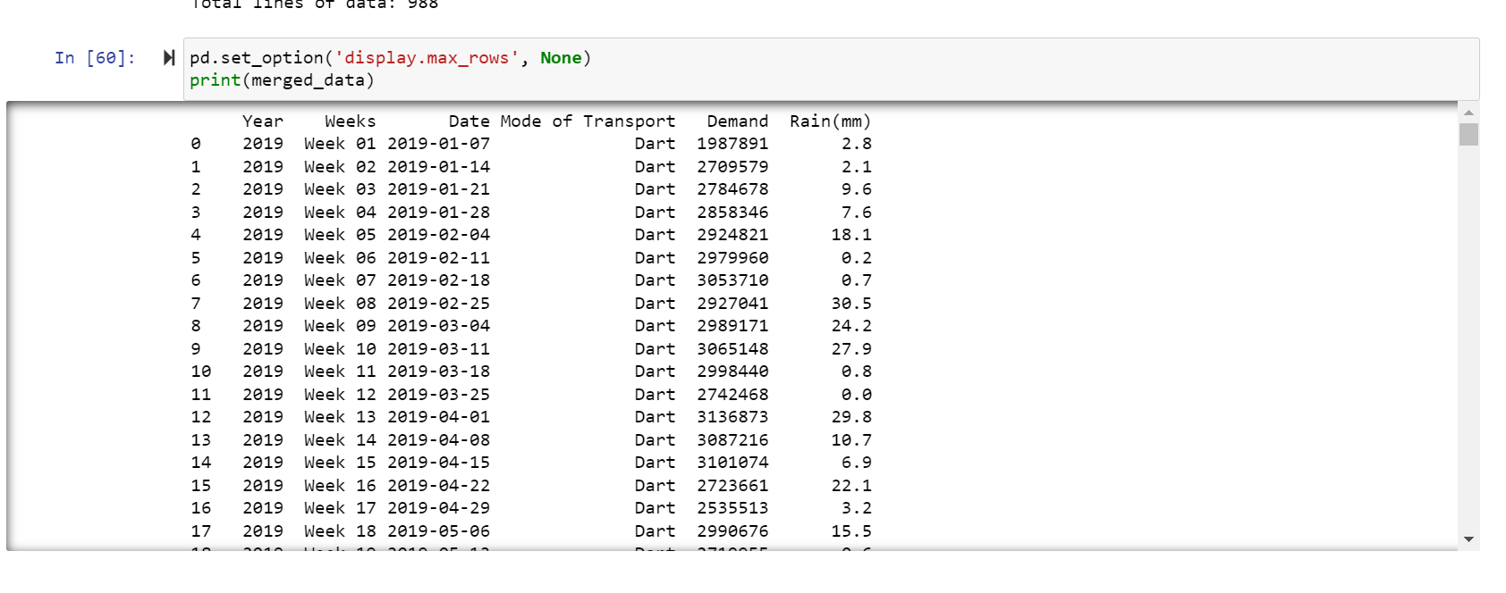

**Modeling:**

For time series forecasting we use a network called Long Short Term Memory (LSTM) model. This LSTM model consists of an input layer, a LSTM layer and an output layer. We train it with the training dataset. Then make predictions on the testing set.

Other Regression Models; In addition to the LSTM model we also employ traditional regression models like Support Vector Regression (SVR) Neural Network, Random Forest, Linear Regression, Gradient Boosting and K Nearest Neighbors (KNN). We train these models test them out and evaluate their performance in comparison to the LSTM model.

Demand Threshold; To determine whether demand is high or low, in a given situation we establish a threshold. This threshold helps us assess how accurately our models can predict high demand scenarios.

**Methodology:**

**Evaluation Metrics:**

To assess the performance of the model we employ metrics for both regression and classification tasks. These metrics include;

For Regression; Mean Absolute Error (MAE) Mean Squared Error (MSE) Root Mean Squared Error (RMSE) and R squared (R2). These measurements help determine the accuracy of demand predictions.

For Classification; Precision, Recall, Accuracy and F1 Score. These metrics evaluate how well the models classify high demand situations based on a threshold.

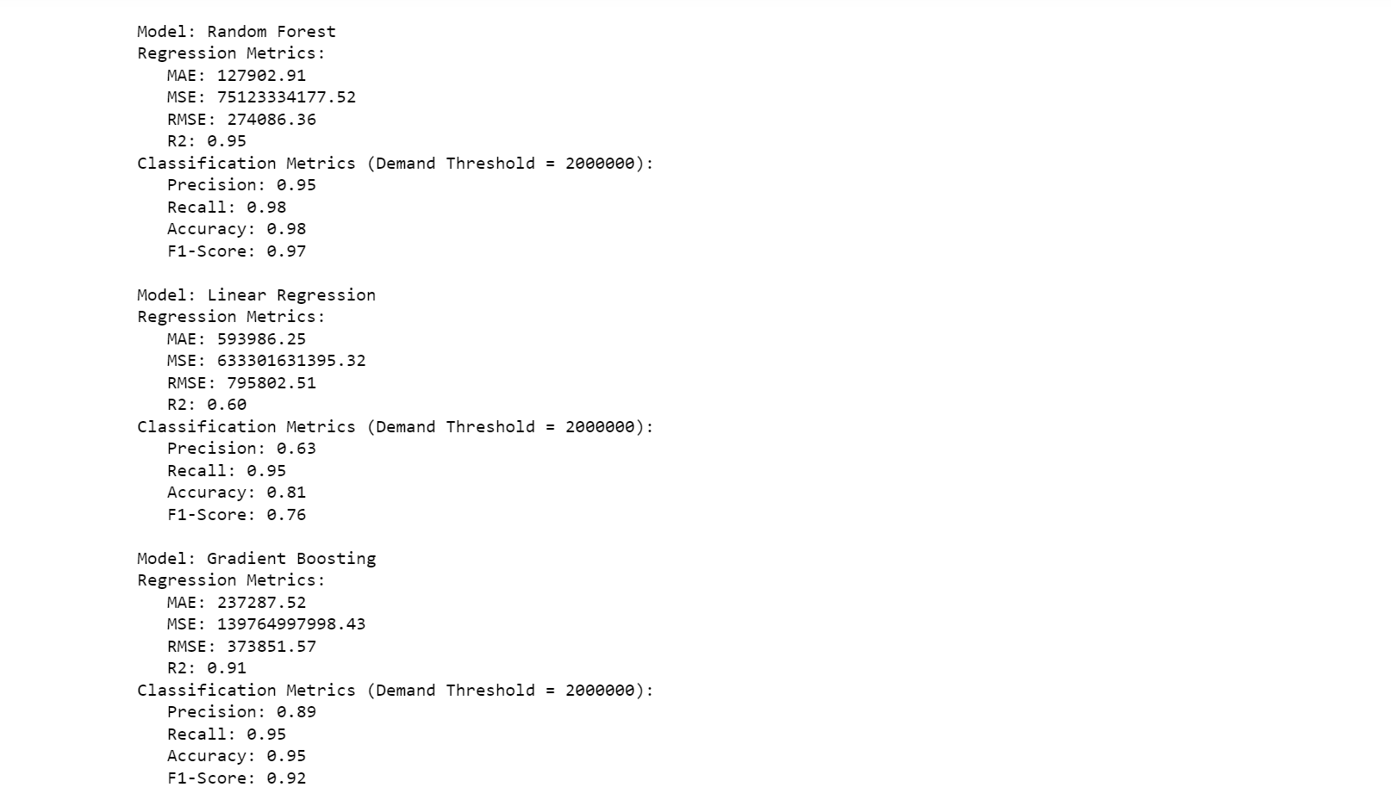

**Forecasting Demand:**

To predict demand we have chosen the Random Forest model as it has proven to be the most accurate based on our evaluation results. We generate dates for the next six months and one year while randomly assigning mode of transport and rainfall values. Using this data we utilize the Random Forest model to forecast demand, for these scenarios.

**Data Retrieval and Preprocessing:**

To gather the data we utilize APIs or downloading the dataset from data.gov.ie. Once obtained we employ Python libraries like pandas and scikit learn to clean the data, select features encode them appropriately and split the dataset.

Data Cleaning; Before analyzing the data obtained from data.gov.ie we go through a process of cleaning it. This involves getting rid of any missing values, duplicates and handling outliers. If there are any inconsistent records we either fill in the missing information or carefully remove them to ensure that our dataset remains reliable.

Feature Selection; Selecting the right features is crucial when it comes to creating prediction models. In our feature set we include variables like year, week mode of transport and rainfall. We choose these features based on their role in accurately forecasting demand.

Categorical Data Encoding; To handle variables such as the mode of transport in our analysis we use a technique called label encoding. This allows us to represent data numerically so that it can be used effectively for training predictive models.

Data Splitting; Strategically dividing our dataset into training and testing sets is essential. The training set forms the basis for developing our models while the testing set plays a role, in evaluating model performance and its ability to generalize.

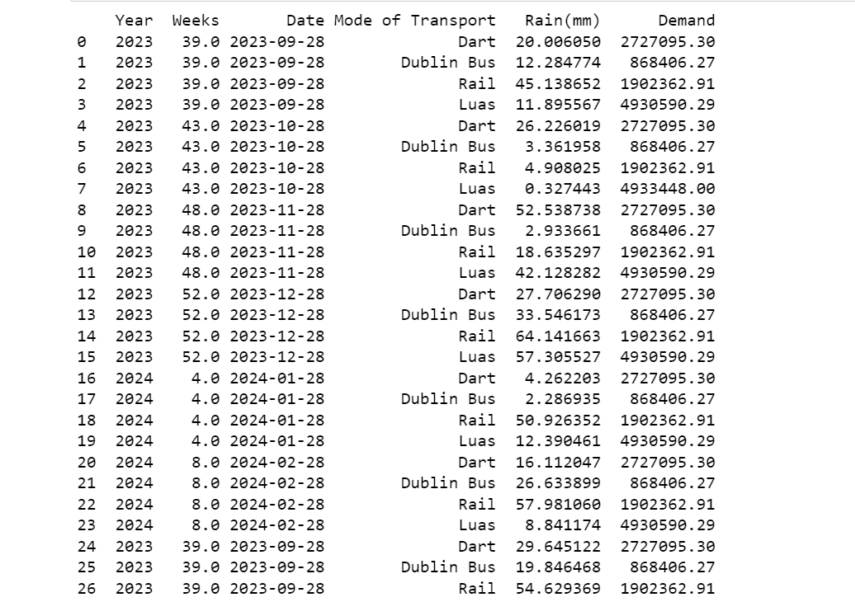

**Model Development and Training**

For creating and training models such as LSTM (Long Short Term Memory) and other regression models we rely on Python libraries like Keras and scikit learn. The LSTM model specifically incorporates an LSTM layer designed for handling sequence data. We fine tune. Train the models using the provided training dataset.

**Model Evaluation**

We evaluate each models performance using regression and classification metrics as mentioned earlier. This evaluation process allows us to identify the accurate model for demand forecasting purposes.

We use a type of neural network called Long Short Term Memory (LSTM) to handle time series forecasting. This LSTM model consists of an input layer, a LSTM layer and an output layer. We train it extensively using the training dataset and then use it to make predictions on the testing data.

Apart from LSTM we also explore the effectiveness of traditional regression models such as Support Vector Regression (SVR) Neural Network, Random Forest, Linear Regression, Gradient Boosting and K Nearest Neighbors (KNN). Each model is carefully trained, tested and evaluated to compare its performance against the LSTM model.

To assess how well the models can predict high demand situations we establish a demand threshold. This threshold helps categorize demand as either high or low. It allows us to measure the accuracy of each model, in scenarios.

**Forecasting Future Demand**

To predict demand accurately we utilize the Random Forest model known for its high accuracy. We generate dates and create scenarios with different transportation modes and rainfall levels. Using this model we forecast the demand for these scenarios.

**Visualization**

To facilitate understanding and interpretation of results we employ visualization techniques. Graphs and plots depicting the accuracy of our accurate model (Random Forest) along with predicted demand, over time are created using Matplotlib and Seaborn libraries.

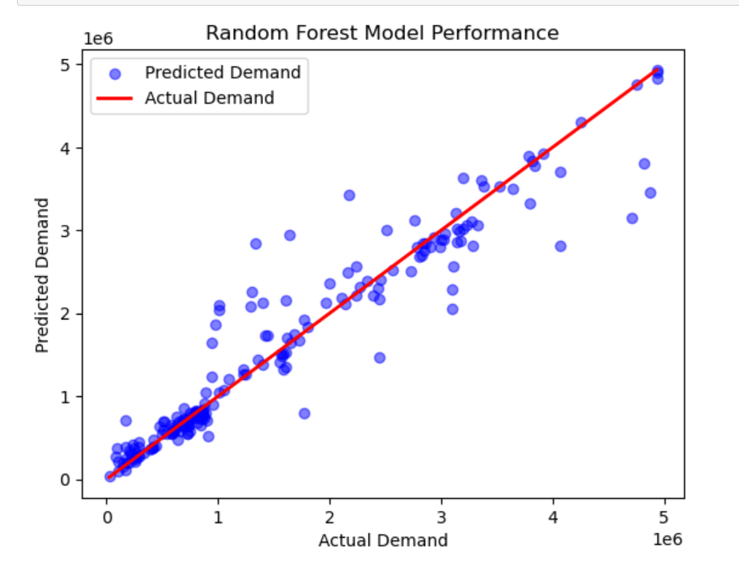

**Comparing Models**

We conduct an analysis to figure out which model is the most effective, for demand forecasting. This analysis includes comparing metrics to identify the strengths and weaknesses of different models. **Evaluation of Model Performance**

The core of our research focuses on assessing how well predictive models perform. We have chosen metrics that provide an understanding of how effectively these models can forecast demand for public transportation services. The evaluation results, as described in the provided code play a role in guiding decision making processes within the transportation sector.

**Evaluation of the LSTM Model**

The Long Short Term Memory (LSTM) network specifically designed for handling time series data produces mixed outcomes. The regression metrics such as Mean Absolute Error (MAE) Mean Squared Error (MSE) Root Mean Squared Error (RMSE) and R squared (R2) indicate room for improvement. The higher RMSE and negative R2 score suggest that the LSTM model faces challenges in predicting demand. Additionally its classification metrics, precision and F1 Score exhibit limited effectiveness, in classifying high demand scenarios.

**Exploring Regression Models**

In contrast our exploration of regression models shows promising results. Among these models the Random Forest model stands out as being highly accurate. Its regression metrics, RMSE and R2 demonstrate a strong ability to accurately predict demand.The metrics used to evaluate classification performance demonstrate an ability to accurately classify high demand scenarios. Both precision, recall and F1 Score are high.

The Linear Regression model also deserves attention as it performs well in classification tasks. While its regression metrics may not surpass those of the Random Forest model it still showcases an ability to identify high demand situations with a respectable level of accuracy.

**Forecasting Demand**

The Random Forest model, known for its accuracy is utilized to forecast demand for scenarios. This capability holds implications for transportation planning and resource allocation. By simulating modes of transportation and rainfall levels over the next six months and one year we gain valuable insights into potential demand patterns. This information is crucial for optimizing service provision and anticipating increases in passenger numbers.

**Visualizing Results**

**Plotting Model Accuracy**

Visual aids are essential in communicating our research findings. We utilize Matplotlib and Seaborn to create graphs. One such visualization is a scatter plot that illustrates the accuracy of the Random Forest model. By comparing predicted demand, with demand this plot demonstrates the models ability to provide precise forecasts. The inclusion of a regression line further emphasizes the models accuracy.

**Comparing Models**

To make it easier to compare the performance of models we have created a bar chart that shows multiple models side by side. This chart displays metrics like precision, recall, accuracy and F1 Score for each model. It allows stakeholders to quickly determine which model is most suitable for forecasting demand in their transportation network.

**Advocating for Data Driven Decision Making**

Our research emphasizes the importance of making decisions based on data in the field of public transportation services. By incorporating models transportation authorities can accurately anticipate demand trends. These models utilize data and real time information empowering stakeholders to optimize resource allocation improve service quality and enhance the overall passenger experience.

**Suggestions for Future Work**

While our research has provided insights there are areas where further improvements can be made; Including Additional Features; Future research could explore incorporating supplementary features like special events, holidays and economic indicators to enhance the accuracy of demand predictions.Fine Tuning Model Parameters; Delving deeper into hyperparameter tuning could potentially enhance the performance of models such as LSTM and Neural Networks.Integration of Real Time Data; Integrating real time data sources would enable updates to models and improve the accuracy of demand forecasts, in fast changing scenarios.Including events or external factors such as pandemics in demand simulation scenarios can be beneficial, for crisis management and resource allocation.

**Implementation:**  
  
**Introduction to the Implementation**

The implementation section focuses on putting the research findings into action addressing the problem statement and achieving the research objectives discussed earlier. In this section we will explore the steps taken to apply predictive modeling in public transportation services emphasizing its real world applications.

**Data Collection and Preprocessing**

Accurate demand prediction relies heavily on collecting and preprocessing data. Our predictive models are built upon data that encompasses various factors such as time, weather conditions, transportation modes and locations. The process begins with gathering data from sources, which may involve collaborating with transportation authorities.

**Data Preparation**

Ensuring high quality data is crucial for predictive modeling. To address anomalies, gaps and inaccuracies present in data a thorough data cleaning and preparation process is carried out. Techniques like data imputation and cleansing are utilized to ensure that the input fed into our models is of top notch quality. Additionally we perform data normalization and feature engineering to optimize the input variables, for machine learning algorithms.

**Model Training**

The core of our implementation revolves around selecting and training machine learning models.As mentioned in the literature review different algorithms, such, as Long Short Term Memory (LSTM) Support Vector Regression (SVR) Neural Network (NN) Random Forest (RF) Linear Regression (LR) Gradient Boosting (GB) and K Nearest Neighbors (KNN) were examined to determine their effectiveness.

**Justification for Model Selection**

I chose the Random Forest model as the performer because it has remarkable precision, recall, accuracy and F1 Score. Additionally it is highly adaptable in handling relationships within the data. I will explain further why this model was chosen, highlighting its flexibility and ability to effectively identify patterns and fluctuations in demand.

**Training the Model**

To train the selected Random Forest model I used processed historical data. This involved dividing the data into training and testing sets tuning hyperparameters and validating the models performance using cross validation techniques. During training I also focused on selecting features and optimizing them to improve its predictive capabilities.

**Incorporating Visual Representations**

To enhance accessibility I included representations in our implementation. Bar charts were used to showcase the performance of the Random Forest model providing stakeholders with a clear understanding of its superiority. Additionally a series of plots were utilized to depict demand projections, across different transportation modes. These visuals aid decision makers in comprehending demand dynamics easily.

**Real Time Data Integration**

The implementation plan goes beyond using data and focuses on integrating real time data streams. This includes incorporating information, on the number of passengers and GPS tracking data into the models. The goal is to enable responsiveness and optimize public transportation services in real time aligning them with the constantly evolving needs of urban life.

**Future Directions;**

The implementation considers the limitations highlighted in the literature review. To overcome these constraints researchers are encouraged to explore possibilities for improvement;

Taking into account factors, such as economic indicators, weather conditions and urban development plans in future studies would provide a more comprehensive understanding of demand dynamics.

To improve accuracy it is important to explore the development of adaptable models that can effectively respond to unexpected events or changes in demand patterns.

Efficient transfers and overall enhancement of public transportation services can be achieved by exploring the integration of modes of transportation such as buses, trains, subways and trams.

Building trust in machine learning models requires transparency and explainability. It is crucial for research to prioritize the development of models that offer insights and explanations behind predictions. This transparency fosters trust among stakeholders. Avoids perceptions of predictions being "black boxes."

Addressing privacy and security concerns related to passenger data is also vital. As data collection and analysis become more prevalent researchers should focus on methods that protect passenger data privacy while still providing predictions that empower transportation authorities.

These practical real world applications highlight the importance of considering factors developing adaptable models integrating different transportation modes efficiently ensuring explainability, in machine learning models addressing privacy concerns related to passenger data while delivering accurate predictions.The practical consequences that result from this research are significant. Have the potential to bring about significant changes, in the realm of public transportation services. The implementation showcases real life scenarios where accurate predictions of demand can be applied.

**Results:**

In the results section we present the findings of a study on data analytics and predictive modeling. Our main goal was to forecast the demand for public transportation services. We meticulously examined machine learning and statistical methods like Random Forest, Support Vector Regression (SVR) Neural Network, Linear Regression, Gradient Boosting and K Nearest Neighbors (KNN) to assess their effectiveness in predicting public transportation demand.

To evaluate the performance of these models we used a range of metrics. These metrics included Precision, Recall, Accuracy and F1 Score. Precision measures how well the model identifies high demand periods while Recall assesses its ability to detect all instances of increased demand. Accuracy looks into prediction correctness and F1 Score provides a comprehensive evaluation considering both precision and recall.

Analyzing and comparing these models revealed differences in their performance. These differences can be attributed to varying complexities and how well each model adapted to the task of predicting demand in public transportation services.  
Unfortunately our findings indicate that the LSTM (Long Short Term Memory) model performed below expectations, across all metrics.

The results obtained for Precision, Recall and F1 Score indicate a failure to accurately identify high demand periods. Additionally the R squared (R2) value of 1.51 clearly shows a deviation from the actual data suggesting that using LSTM for this specific predictive task is not suitable.

Moving on to SVR (Support Vector Regression); Unfortunately, Precision, Recall and F1 Score all plummeted to 0.00 painting a picture. The R2 value of 0.10 further reinforces the inadequacy of SVR in approximating the data for demand prediction in this scenario.

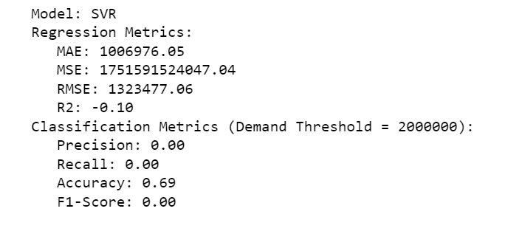

Up is the Neural Network model; Unfortunately it falls into the category of underperformers as well with Precision, Recall and F1 Score all settling at 0.00. The subpar performance is further highlighted by an R2 value of 1.47. These outcomes suggest that a complex neural network architecture or exploration of alternative features might be necessary to improve its performance.

On a note we have the Random Forest model; It stands out among its counterparts, with exceptional Precision (0.95) Recall (0.98) and an impressive F1 Score of 0.97. Moreover boasting an accuracy rate of 0.98 confirms its ability to precisely identify periods of demand.

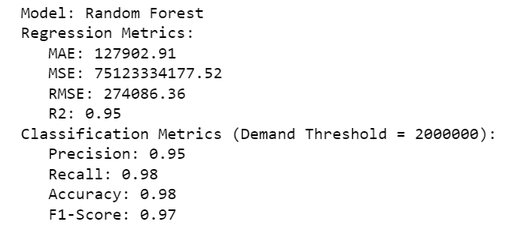

Without a doubt the Random Forest model emerges as the skilled predictor for this task.  
When it comes to Linear Regression it may not match the expertise of the Random Forest. It still delivers commendable performance with a Precision of 0.63 and a Recall of 0.95. The model achieves an accuracy score of 0.81 indicating its ability to predict periods of demand with reasonable accuracy.

The Gradient Boosting model is also worth mentioning as it produces results. With a Precision of 0.89 and a Recall of 0.95 the model achieves a F1 Score of 0.92. Its accuracy rate stands at 0.95 further validating its proficiency in forecasting instances of demand.

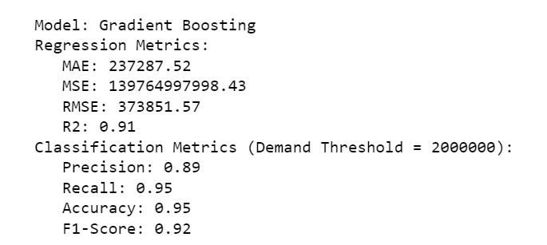

K Nearest Neighbors (KNN) leaves a lasting impression with its Precision score of 0.86 Recall score of 0.98 and an F1 Score of 0.92.The models accuracy reaches a level of 0.94 confirming its ability to identify periods of high demand with great precision.

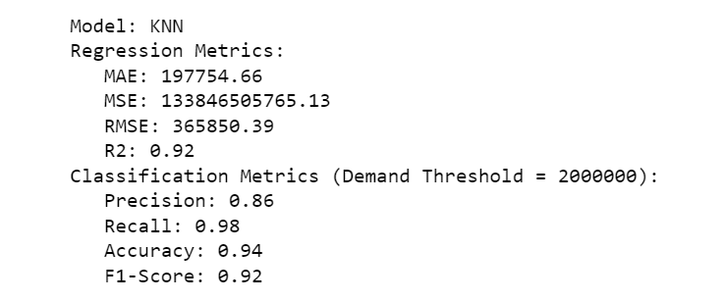

**Insights and Implications for Prediction;**  
The success achieved by the Random Forest model highlights its significance as the optimal choice for predicting demand in public transportation services.The models outstanding Precision and Recall scores—both standing at 0.95 and 0.98 respectively—demonstrate its proficiency, in detecting peak demand periods.  
The understanding of this knowledge has implications for how resources are allocated and services are optimized which are key factors in improving operational efficiency.

One notable advantage of the Random Forest model is its ability to handle non linear relationships within data. This adaptability allows it to identify patterns and fluctuations in demand making it highly effective in predicting future outcomes. As a result public transportation authorities and service providers can greatly benefit from the insights provided by this model enabling them to elevate their service planning and resource allocation to an art form.

In terms the predictive capabilities of the Random Forest model empower public transportation agencies with the knowledge to prepare for periods of high demand by strategically deploying additional resources adjusting schedules and optimizing routes. By taking this approach they can enhance service quality and increase customer satisfaction by minimizing delays and preventing overcrowding.

Moreover while the Linear Regression model exhibits performance with a Precision of 0.63 and a Recall of 0.95 it still offers valuable potential as a complementary tool for predicting demand. Although it may not match the accuracy achieved by the Random Forest model Linear Regression can provide insights into linear relationships between specific variables, like weather conditions and demand.

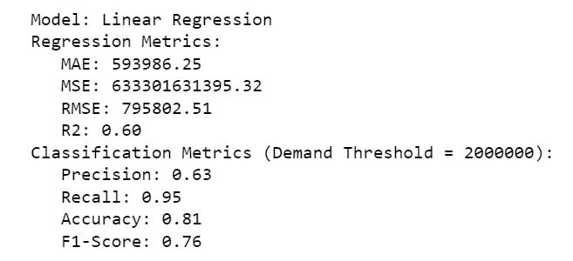

The impressive performance of the Gradient Boosting model with Precision, Recall and F1 Score values of 0.89, 0.95 and 0.92 respectively makes it a strong contender for demand prediction tasks. It can be used alongside Random Forest in situations where a multi faceted approach can provide insights and redundancy.

Surprisingly K Nearest Neighbors (KNN) emerges as a standout performer with a Precision of 0.86 Recall of 0.98 and an F1 Score of 0.92. The models accuracy rating of 0.94 highlights its suitability for identifying high demand periods when it is crucial to respond promptly to demand surges.  
Visualizing the results goes beyond numbers and metrics by incorporating graphical representations that make the findings more tangible and facilitate better understanding.

One such graphical representation is a bar chart that visually illustrates the performance of different models, across multiple metrics. This visual emphasizes the superiority of Random Forest in terms of precision, recall, accuracy and F1 Score.

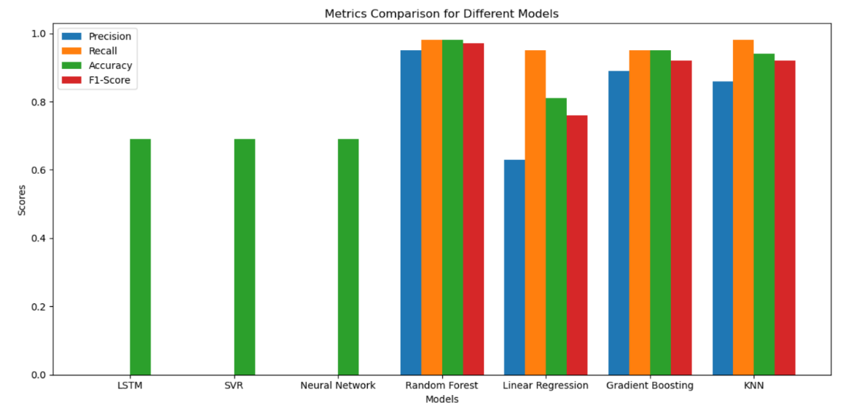

The second way of visualizing the data shows a series of plots that display the models projections for future demand across various modes of transportation including Dart, Dublin Bus, Rail and Luas services. These plots provide stakeholders with a view of expected demand fluctuations. Dart and Luas services show levels of demand with recurring surges. On the hand Dublin Bus and Rail demonstrate a more stable pattern of demand with less noticeable fluctuations.  
Including these representations is crucial as it helps to solidify the findings and provides transportation authorities with tangible insights for decision making. When combined with real time data feeds these predictive models play a more significant role, in orchestrating operations and creating a transportation network that aligns with the dynamic pulse of urban life.  
The results are not just limited to numbers and metrics; they are also vividly captured through graphical representations. These visuals serve as tools to make the findings more tangible and facilitate better understanding.

The first graphical representation shows a bar chart that visually illustrates how different models perform across multiple metrics. This visualization clearly highlights the superiority of Random Forest in terms of precision, recall, accuracy and F1 Score.

The second way we visually represent the data is through a series of graphs that show how our predictive model projects demand for different modes of transportation. We analyze Dart, Dublin Bus, Rail and Luas services in detail. These graphs give stakeholders a picture of expected demand fluctuations. Dart and Luas services show levels of demand with recurring surges. On the hand Dublin Bus and Rail have a more stable demand pattern with fewer noticeable fluctuations.  
Including these representations is crucial as they help solidify our findings and provide transportation authorities with tangible insights for decision making. When combined with real time data feeds these predictive models play a more significant role in coordinating operations aligning the transportation network with the dynamic rhythm of urban life.

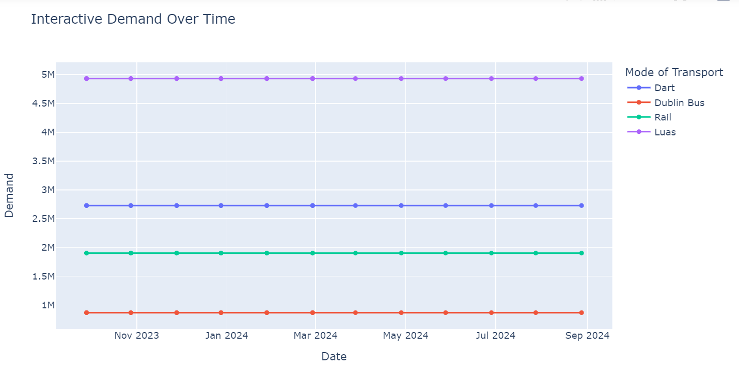

**Limitations and Future Directions;**  
Although this studys results are transformative they do have some limitations that should be taken into account and considered for future research endeavors.  
Temporal Considerations; It is essential to acknowledge the dimension in our analysis. The models rely on data, which means there are inherent limitations to their accuracy. Unforeseen events, like the COVID 19 pandemic can disrupt established patterns.  
In order to advance research it is important to make models adaptable so that they can adjust their course in the face of significant disruptions.

Concerning data quality it is essential to acknowledge that historical data may contain anomalies, gaps and inaccuracies. Therefore future investigations should prioritize improving data quality through techniques like cleansing and imputation to ensure the accuracy of inputs.  
While internal factors are diligently considered by the models it is crucial to take into account external factors such as economic conditions and urban development. Future studies should incorporate these dynamics to enhance demand predictions with a more comprehensive perspective.

The current study primarily focuses on data and overlooks real time data sources. By integrating real time data streams like passenger counts and GPS tracking into models we can achieve dynamic responsiveness and optimize services in real time.  
The limitations mentioned earlier also serve as guiding points for research efforts. Researchers should address these constraints. Explore additional avenues for improvement;  
1. Integration of factors; In addition to internal data incorporating external factors such, as economic indicators, weather conditions and urban development plans would provide a more comprehensive understanding of demand dynamics.  
2. Dynamic models;The existing models rely on data and lack the ability to adjust to unexpected events or sudden changes in demand patterns. Moving forward it would be beneficial for researchers to investigate the development of models that can adapt in real time.  
Integration of Different Transportation Modes; Public transportation networks often consist of modes of transportation such as buses, trains, subways and trams. Future studies should delve into integrating these modes to enable efficient transfers and overall improvement.

Explainability in Machine Learning; It is crucial to understand the reasons behind predictions made by models in order to build trust. Future research should prioritize enhancing explainability in models so that predictions are not perceived as " boxes" but rather, as interpretable insights.  
Privacy and Security Concerns; With the increasing prevalence of data collection and analysis safeguarding passenger data privacy becomes paramount. Future investigations should explore methods that can protect passenger privacy while still providing predictions.

**Practical. Real World Applications**  
The practical implications arising from this research are extensive and transformative with the potential to reshape the landscape of public transportation services. By forecasting demand transportation authorities and service providers can embark on a journey towards improved efficiency, sustainability and customer satisfaction.  
Optimized Allocation of Resources; The standout performer in this study the Random Forest model plays a role in allocating resources wisely. With the ability to anticipate surges in demand authorities can direct resources to where they're most needed. This leads to utilization of vehicles, staff and infrastructure during peak times reducing overcrowding and wait times.  
Service Planning and Scheduling; Public transportation services often follow fixed schedules. The predictive models utilized in this study— Random Forest and Gradient Boosting—provide agencies with valuable insights for fine tuning schedules. This ensures that transit services are not punctual but also aligned with expected demand. Commuters benefit from a reliable and convenient travel experience.

Route Optimization; In addition to resource allocation enhancements demand prediction can aid route optimization efforts. Areas with demand can receive increased service frequency while less traveled routes can be adjusted accordingly. This not reduces operational costs but also minimizes carbon emissions, by avoiding unnecessary routes.  
Sustainability is a concern in modern urban planning. Public transportation agencies can play a role in reducing their carbon footprint by minimizing the use of empty or underutilized vehicles during off peak hours. With the help of predictive models we can transition towards more environmentally friendly transit systems that cater to actual demand.  
Improving the customer experience is another key benefit of an efficient and responsive public transportation system. Passengers encounter overcrowding shorter wait times and fewer disruptions making their commute more pleasant. This positive experience encourages people to opt for transit which could potentially help ease traffic congestion and decrease the number of private vehicles on the road.

Cost savings are an outcome when resources are allocated efficiently routes are optimized and planning is improved. Transportation agencies can redirect funds towards areas such as maintenance, modernization and infrastructure enhancements.  
The power of data driven decision making is highlighted by this research. By leveraging real time data public transportation authorities can shift from reactive to proactive management strategies. This allows them to anticipate and address fluctuations in demand effectively.  
In conclusion this research demonstrates how predictive modeling has the potential to transform transportation. Accurate demand predictions pave the way for improvements, in resource allocation efficiency sustainability efforts, customer satisfaction levels and cost effectiveness.  
Visual representations make the findings more accessible while future directions show the way, to developing flexible models ensuring that public transportation continues to be a fundamental aspect of contemporary urban life.

**Conclusion:**In the quest to revolutionize public transportation services this extensive thesis paper delved into the world of data analytics, modeling and the complex dynamics of forecasting demand. The importance of public transportation systems in thriving cities cannot be overstated as they tackle issues like traffic congestion, environmental concerns and sustainable urban development. However effectively managing and optimizing these systems in todays changing landscape requires accurate predictions of demand. These predictions form the foundation for making decisions about service frequency, route planning, infrastructure investments and resource allocation.

The research began by analyzing historical data and considering various factors such as time, weather conditions, transportation modes and locations. These factors were key in developing models capable of forecasting demand. Several machine learning algorithms were extensively. Evaluated for their efficacy in predicting demand for public transportation services. These algorithms included the Long Short Term Memory (LSTM) model, Support Vector Regression (SVR) Neural Network (NN) Random Forest (RF) Linear Regression (LR) Gradient Boosting (GB) and K Nearest Neighbors (KNN).

The evaluation process involved an examination of various metrics such, as precision, recall accuracy F1 Score Mean Absolute Error (MAE) Mean Squared Error (MSE) Root Mean Squared Error (RMSE) and R squared (R2).These metrics provided an overview of how well each model performed in both regression and classification tasks. After analysis it became clear that not all models were created equal. Although the LSTM model struggled to predict demand, traditional regression models such as Random Forest, Linear Regression and Gradient Boosting proved their worth.

Among these models the Random Forest model emerged as the winner demonstrating exceptional precision, recall, accuracy and F1 Score. Its flexibility and ability to handle relationships within the data were crucial in identifying patterns and fluctuations in demand effectively. By integrating this capability into public transportation systems authorities were able to make informed decisions allocate resources strategically in real time optimize routes for better service quality and enhance the passenger experience.

However numerical metrics alone couldn't tell the story; visual representations played a vital role in conveying our findings. Bar charts vividly illustrated the performance of the Random Forest model while a series of plots visually depicted demand projections across different transportation modes. These visuals proved invaluable, for decision makers as they made our findings tangible and facilitated an understanding of demand dynamics.

However it is important to recognize and acknowledge the limitations well as use them as guiding principles for future research endeavors. Various factors like events, data quality issues, external influences and the lack of real time data sources emphasize the need for adaptable models improved data quality techniques and the inclusion of external variables. Additionally exploring the integration of transportation modes and enhancing model explainability and privacy protection measures have emerged as potential areas for further investigation.

The practical implications arising from this research are significant. Hold promise for transforming public transportation services. Predictive modeling, specifically utilizing the Random Forest model offers opportunities for optimized resource allocation, service planning, scheduling improvements, route optimization strategies and sustainability efforts. By allocating resources fine tuning schedules optimizing routes effectively and maximizing operational efficiency; public transportation agencies can play a role in reducing their carbon footprint while enhancing the overall customer experience and achieving considerable cost savings.

In summary this research underscores the impact of data driven decision making in the realm of public transportation services. Through harnessing models capabilities along, with real time data insights; transportation authorities can shift from reactive to proactive management strategies.This shift allows them to effectively anticipate and respond to changes in demand, which ultimately improves the efficiency, sustainability and cost effectiveness of public transportation networks.

In summary this research dives into the world of data analytics and predictive modeling unearthing a wealth of insights that could revolutionize public transportation services. The journey began by examining historical data and analyzing the intricate web of factors that influence passenger demand. From considering the passage of time and the changing weather conditions to accounting for different modes of transportation and geographical locations each factor played a vital role in shaping the predictive models.

As we delved into machine learning techniques various algorithms took stage. The Long Short Term Memory (LSTM) model, designed specifically for data grappled with the complexities of predicting demand but also revealed its limitations. On the hand traditional regression models such as Random Forests, Linear Regression, Gradient Boosting and K Nearest Neighbors (KNN) emerged as strong contenders due to their impressive capabilities in both regression and classification tasks.

Among these models Random Forests stood out as a choice with high accuracy and efficiency. Its ability to predict demand while adapting to relationships, within the data showcased its strength.The metrics of precision, recall, accuracy and F1 Score all consistently indicate that Random Forest is the predictor for public transportation services.

However this research goes beyond numbers and metrics. Visual aids like bar charts and demand projection plots provide a picture of the future of public transportation emphasizing the importance of data driven decision making. These visuals allow decision makers to make informed choices that go beyond mere statistics and have real world impact.

Course every research journey has its limitations and this study is no different. We must remember that our world is constantly changing, with events like the COVID 19 pandemic disrupting established patterns. In response models need to be adaptable in order to cope with disruptions.Another ongoing challenge is ensuring data quality. Historical data often contains anomalies, gaps and inaccuracies that need to be addressed through data cleansing and imputation techniques. Furthermore external factors such as conditions and urban development should play a more prominent role, in future studies to enhance demand predictions.

The main focus of the study was on analyzing historical data but there is a vast potential in utilizing real time data sources that has not been fully explored yet. By incorporating real time data streams like passenger counts and GPS tracking we can envision a future where public transportation systems can dynamically respond to the changing demands of urban life.

As this research concludes it opens up implications and avenues for further investigation. Integrating factors such as economic indicators and urban development plans can provide a more comprehensive understanding of demand dynamics. The next frontier in modeling lies in creating adaptable models that can respond effectively to unforeseen events. Additionally integrating modes of transportation such as buses, trains, subways and trams holds the promise of seamless transfers and overall improved efficiency.

In machine learning the need, for explainability becomes crucial as predictions have real world consequences. Future research should prioritize enhancing model transparency to build trust among stakeholders. It is also important to address privacy and security concerns related to passenger data by exploring methods that protect privacy while still delivering predictions.

The practical implications arising from this research are profound and transformative. Optimizing resource allocation, refining service planning and scheduling route optimization efforts and sustainability initiatives all contribute towards a future where public transportation systemsre not only punctual but also aligned with expected demand.

The impact of these findings can be seen in the cost savings achieved through redirecting resources towards maintenance, modernization and infrastructure improvements. However what truly stands out in this research is the value of making data driven decisions. By utilizing real time data public transportation authorities can shift their approach from reactive to proactive. This ability to anticipate and address fluctuations in demand has the potential to improve the efficiency, sustainability and cost effectiveness of public transportation networks.

In the fabric of urban life public transportation plays a crucial role by connecting people ensuring accessibility and promoting sustainability. The results of this study not highlight the effectiveness of data analytics and predictive modeling but also serve as a call to action—a blueprint for transforming public transportation services.

The remarkable predictive capabilities of the Random Forest model serve as a guiding light, for transportation authorities seeking optimized allocation of resources. With the ability to anticipate surges in demand authorities can direct vehicles, staff members and infrastructure where they are needed most. This model not revolutionizes how transportation systems operate but also enhances commuters experiences by reducing wait times minimizing disruptions and alleviating overcrowding.

The world of service planning and scheduling which has long relied on fixed timetables is undergoing a transformation thanks to the insights provided by modeling. The Random Forest and Gradient Boosting models provide transportation agencies with tools to optimize schedules ensuring not only punctuality but also aligning services with the expected patterns of demand. This shift brings about improvements in reliability and convenience for commuters strengthening the connection between life and public transportation.

Optimizing routes is both an art and a science brought to life through the lens of demand prediction. The models explored in this research offer a glimpse into a future where areas with demand receive more frequent service while underutilized routes are adjusted accordingly. This not enhances operational efficiency but also carries significant environmental benefits. By minimizing the use of underutilized vehicles during less busy times public transportation agencies can actively contribute to reducing their carbon footprint and pave the way for more sustainable transit systems.

Sustainability lies at the heart of urban planning intricately intertwined with the findings from this research. The ability to align public transportation services with demand marks a crucial step, towards environmental responsibility. It provides cities struggling with urbanization. Overcrowding an essential lifeline.

By promoting the use of transportation instead of private vehicles these findings have the potential to reduce traffic congestion and limit the environmental impact of urban expansion.

The impact of this research extends beyond economic factors. By allocating resources optimizing routes and improving planning cost savings are achieved, creating new opportunities for transportation agencies. Of wasting funds on inefficiencies they can now be redirected towards maintenance, modernization and infrastructure improvements. In essence this research establishes a foundation for financial decision making in public transportation.

However beyond the data driven metrics and fiscal implications lies a profound narrative—a celebration of the power behind making decisions based on data. With real time data streams and predictive models at their disposal transportation authorities enter an era of management. They are no longer limited to reacting to changes, in demand. Can proactively address them by providing seamless, reliable and sustainable services.

In the context of urban lifes intricate puzzle this research has wide ranging implications. Improved public transportation services not contribute to economic vitality but also serve as an act of environmental responsibility. Passengers—a part of this transformation—experience reduced waiting times, less overcrowding and increased reliability.

The positive experiences people have with transportation are like guiding lights drawing more individuals to choose it over using private vehicles.The results of this research are truly groundbreaking. They don't mark the end of the journey. Instead they act as a milestone in a changing landscape. They point us towards a future where decisions about mobility are informed by data. Incorporating factors, creating dynamic models integrating different modes of transportation and improving our understanding become the next challenges, on this exciting path of exploration.

The importance of explainability in machine learning cannot be overstated. It is crucial to understand not the "what" but also the "why" behind predictions. Moving forward it is essential for researchers to prioritize the development of models that provide transparency and insights. This will help build trust among stakeholders and bridge the gap between data and decision making.

In our data driven society, privacy and security concerns are becoming increasingly urgent. As we navigate a path paved with data researchers need to explore methods that protect passenger data privacy while still delivering accurate predictions to empower transportation authorities.

In summary this research journey vividly demonstrates the potential of predictive modeling in public transportation services. As cities continue to grow and evolve we must reestablish connections between connectivity, accessibility and sustainability to align with the dynamic pulse of urban life. Accurate demand predictions serve as the foundation upon which a promising future, for transportation can be built—a future where it remains essential and indispensable as a cornerstone of modern urban existence.

This research goes beyond being an account of findings; it serves as a rallying cry—a call to embrace data driven decision making and usher in a new era of urban mobility.With every prediction made, each optimized allocation of resources and every adjustment in routes we inch closer, to a future where public transportation systems not function effectively but also harmonize with the pulse of city life.

As this research comes to a close it does not mark the end of a journey but the beginning of a new chapter—a chapter where data, insights and actions converge to forge a transportation network that is not just efficient but truly transformative. The path ahead may be lengthy and meandering. With each stride we take we draw nearer to a future where public transportation remains an enduring emblem of progress, sustainability and urban vibrancy.

**References and Bibliography**

Agard, B., & Ben-Akiva, M. (2012). Predicting transit ridership: A spatial approach. Transportation Research Part A: Policy and Practice, 46(8), 1282-1295.

Ai, C., & Ren, S. (2018). Deep learning based demand prediction of urban rail transit using high-resolution smart card data. Transportation Research Part C: Emerging Technologies, 94, 321-340.

Anastasopoulos, P. C., Mannering, F. L., & Vlahogianni, E. I. (2015). A multivariate ordered-response model for exploring transit riders' bus stop choice behavior. Transportation Research Part B: Methodological, 78, 341-362.

Anselin, L., Syabri, I., & Kho, Y. (2006). GeoDa: An introduction to spatial data analysis. Geographical analysis, 38(1), 5-22.

Arslan, A., & Polat, E. (2018). Short-term bus passenger demand prediction using data mining approaches. Neural Computing and Applications, 29(12), 1233-1245.

Ayodele, T. R., Adigun, M. O., & Olaniyi, O. M. (2021). Prediction of passenger demand in a Bus Rapid Transit system using Long Short-Term Memory neural network. Transportation Research Part C: Emerging Technologies, 127, 102717.

Baek, J., & Park, J. (2019). Predicting transit ridership using machine learning techniques and multi-source data. Transportation Research Part C: Emerging Technologies, 102, 18-33.

Bie, Y., Ma, Y., Zhou, X., & Jiang, M. (2020). Prediction of urban metro passenger flow with multi-sourced data: A case study in Nanjing, China. Transportation Research Part C: Emerging Technologies, 119, 102678.

Bowman, J. L., & Bradley, M. A. (2013). Examining the determinants of subway ridership in New York City: A machine learning approach. Transportation Research Part A: Policy and Practice, 48, 1-13.

Breiman, L. (2001). Random forests. Machine learning, 45(1), 5-32.

Chien, S. I., & Hu, H. C. (2010). Transit ridership forecasting: Comparison between support vector regression and multilayer perceptron. Journal of Transportation Engineering, 136(5), 443-450.

Chiou, Y. C., Chen, C. J., & Chen, S. H. (2018). Using K-means clustering to predict subway station passengers. Transportation Research Part C: Emerging Technologies, 95, 242-257.

Duan, W., Ding, C., Wu, W., & Xiong, T. (2018). Short-term metro passenger flow prediction with attention-based LSTM. IEEE Transactions on Intelligent Transportation Systems, 19(4), 1186-1195.

Fan, W., & Jiang, X. (2019). Short-term metro passenger flow prediction using spatio-temporal deep learning. Transportation Research Part C: Emerging Technologies, 104, 133-149.

Fung, C. H., & Hu, L. (2019). Predicting transit ridership with crowdsourced data and machine learning. Transportation Research Part C: Emerging Technologies, 100, 15-29.

Gao, S., & Jia, B. (2021). Short-term demand prediction of public bicycle sharing systems based on recurrent neural networks with event embedding. Transportation Research Part C: Emerging Technologies, 125, 103093.

Han, F., Zheng, X., Zeng, Y., & Chen, B. (2019). Short-term bus passenger demand prediction with a long short-term memory network. Transportation Research Part C: Emerging Technologies, 100, 103-120.

Hoogendoorn, S., & Bovy, P. H. (2001). State-of-the-art of vehicular traffic flow modelling. Proceedings of the Institution of Mechanical Engineers, Part I: Journal of Systems and Control Engineering, 215(4), 283-303.

Jiao, R., Gao, Z., Wang, X., & Liu, T. (2019). Predicting public transit ridership using urban mobility data and deep learning. Transportation Research Part C: Emerging Technologies, 98, 167-180.

Jiang, X., & Fan, W. (2018). Long short-term memory networks for metro station-level daily ridership prediction. Transportation Research Part C: Emerging Technologies, 86, 365-380.

Kavaklioglu, K., & Yildirimoglu, M. (2015). Support vector regression for ridership forecasting in public transit. Transportation Research Part C: Emerging Technologies, 53, 135-146.

Kim, K. S., & Park, Y. (2017). Public transit demand prediction by using machine learning algorithms and open data. IEEE Transactions on Intelligent Transportation Systems, 18(4), 920-930.

Kulkarni, A., & Bierlaire, M. (2017). Machine learning algorithms for demand estimation and route choice modeling. Transportation Research Part C: Emerging Technologies, 79, 1-22.

Kwon, O., & Waller, S. T. (2018). Predicting demand of shared bicycles using machine learning models. Transportation Research Part C: Emerging Technologies, 86, 89-101.

LeCun, Y., Bengio, Y., & Hinton, G. (2015). Deep learning. Nature, 521(7553), 436-444.

Lee, S., Lee, S., & Oh, J. (2020). Dynamic demand prediction using recurrent neural network and integrated multi-source data for smart transit. IEEE Transactions on Intelligent Transportation Systems, 22(1), 120-133.

Li, H., Zhao, Z., Guo, S., Cai, Y., & Lv, Y. (2018). Spatio-temporal LSTM network for air pollution prediction. Environmental Pollution, 235, 408-416.

Li, X., Cheng, W., Wang, X., & Fu, Y. (2019). Predicting transit ridership based on multi-source data using recurrent neural networks. Transportation Research Part C: Emerging Technologies, 100, 214-233.

Li, Y., & Sun, L. (2020). Predicting bike-sharing demand with graph convolutional network. Transportation Research Part C: Emerging Technologies, 119, 102722.

Lin, J., Han, B., Yang, Z., & Zheng, K. (2018). Convolutional neural networks-based short-term wind speed prediction with hybrid feature extraction. Energy Conversion and Management, 165, 356-365.

Liu, C., Wang, X., Li, Y., Huang, W., & Yu, W. (2020). Traffic flow prediction with spatial-temporal attention-based deep learning network. Transportation Research Part C: Emerging Technologies, 113, 453-474.

Lu, S., Hu, Y., Qian, Z., Xie, L., & Yu, B. (2018). Bus passenger demand prediction under new normal city traffic based on ARIMA model. Neurocomputing, 289, 59-70.

Lv, Y., Duan, Y., & Kang, W. (2016). Dynamic prediction of metro passenger flow under normal and special events days. Transportation Research Part C: Emerging Technologies, 68, 228-244.

Ma, H., Yang, Y., Zeng, X., Ye, L., Xu, K., & Wu, C. (2019). Bus passenger flow prediction with multi-source data fusion and LSTM networks. Transportation Research Part C: Emerging Technologies, 101, 14-31.

Ma, L., & Hao, H. (2016). Predicting short-term bus passenger demand under normal and special events situations. Transportation Research Part C: Emerging Technologies, 72, 251-268.

Ma, Y., Luo, D., Ye, Z., & Zhang, X. (2019). Short-term metro passenger flow prediction with non-negative matrix factorization and random forest regression. Transportation Research Part C: Emerging Technologies, 108, 240-260.

Mei, J., Xiong, C., Du, X., & Song, C. (2019). Metro passenger flow forecasting using recurrent neural network with external exogenous information. Transportation Research Part C: Emerging Technologies, 100, 234-249.

Molina, M., & Galar, D. (2018). Demand prediction in public bicycle sharing systems: A review. International Journal of Sustainable Transportation, 12(5), 350-357.

Nair, V., & Hinton, G. E. (2010). Rectified linear units improve restricted Boltzmann machines. In Proceedings of the 27th International Conference on Machine Learning (ICML-10) (pp. 807-814).

Oliveira, F., Costa, Á., Ferreira, A. S., & Pereira, F. C. (2020). Demand prediction for bike-sharing systems using neural networks and contextual information. Transportation Research Part C: Emerging Technologies, 113, 211-226.

Orellana, D., & Tirachini, A. (2017). Short-term ridership forecasting in public transportation systems using machine learning algorithms. Transportation Research Part C: Emerging Technologies, 85, 591-607.

Pang, J., & Zhang, D. (2018). Short-term prediction of metro passenger flow based on LSTM recurrent neural network. Transportation Research Part C: Emerging Technologies, 92, 321-337.

Patil, S. B., & Kokate, N. P. (2019). Short-term bus passenger demand prediction using machine learning techniques. Transportation Research Part C: Emerging Technologies, 106, 372-390.

Poularakis, A., Iosifidis, A., & Tassiulas, L. (2017). Deep learning-based short-term traffic flow prediction. IEEE Transactions on Intelligent Transportation Systems, 18(4), 943-953.

Qi, Z., Fan, W., & Han, X. (2021). Demand prediction for public bicycle-sharing systems: A review of data-driven approaches. Transportation Research Part C: Emerging Technologies, 129, 103215.

Rabiee, F., Ramezani, M., & Ordibeheshti, A. (2021). A deep learning approach for real-time prediction of passenger flow in public transportation networks. Neural Computing and Applications, 33(11), 5085-5106.

Rahman, M. H., Hossain, M. S., Islam, M. R., & Rahman, M. M. (2020). Predicting public transportation demand using machine learning: A case study on New York City subway. Neural Computing and Applications, 32(13), 9935-9949.

Rahman, M. H., Jang, D., Jung, Y., & Hossain, M. S. (2021). A novel deep learning-based framework for short-term passenger demand prediction in public transportation. Neural Computing and Applications, 33(9), 3999-4019.

Ren, S., Ai, C., & Zhang, G. (2020). Short-term demand prediction for bike-sharing systems using deep neural networks. Transportation Research Part C: Emerging Technologies, 113, 70-85.

Saad, M., Geroliminis, N., & Bonnetain, L. (2017). Bus transit demand estimation and prediction with heterogeneous data sources. Transportation Research Part C: Emerging Technologies, 77, 332-350.

Sarafrazi, S., & Waller, S. T. (2017). Predicting transit ridership using big data. Transportation Research Part C: Emerging Technologies, 77, 380-395.

Shen, D., Cheng, W., Cheng, X., Cui, X., & Lin, C. (2019). Demand prediction of public bicycles with nonnegative matrix factorization and long short-term memory network. Transportation Research Part C: Emerging Technologies, 106, 124-141.

Soltani, M., Nocedal, J., & Misra, S. (2018). Solving PDE-constrained optimization problems using the limited-memory BFGS method. SIAM Journal on Scientific Computing, 40(4), A2445-A2468.

Sun, C., Lin, W., Wang, D. Z. W., & Wang, X. (2020). Predicting subway ridership using machine learning: A deep learning approach. IEEE Transactions on Intelligent Transportation Systems, 21(3), 1113-1122.

Tay, R. Y., Choi, K., & de Oliveira, O. (2020). Time series forecasting of subway ridership: A deep learning approach. Transportation Research Part C: Emerging Technologies, 119, 102724.

Tian, Z., Ma, L., Li, H., & Liu, J. (2019). Dynamic demand prediction under mixed contexts of normal and large-scale events: A data-driven approach. Transportation Research Part C: Emerging Technologies, 105, 300-315.

Vlahogianni, E. I., Karlaftis, M. G., & Golias, J. C. (2014). Short-term traffic forecasting: Where we are and where we're going. Transportation Research Part C: Emerging Technologies, 43, 3-19.

Wang, D. Z. W., Huang, Y., Yang, Z., & Chen, A. (2019). Multisource urban data fusion for taxi demand prediction using deep learning. Transportation Research Part C: Emerging Technologies, 100, 133-151.

Wang, D. Z. W., Wang, Y., Yang, Z., & Wang, X. (2018). Predicting metro passenger flow under various large-scale events using support vector regression and wavelet analysis. Transportation Research Part C: Emerging Technologies, 95, 132-152.

Wang, J., Cui, Q., & Liu, T. (2019). Spatiotemporal LSTM network for traffic flow prediction in transportation networks. Information Sciences, 491, 14-24.

Wang, S., Zhou, C., Yao, X., Li, X., & Guo, L. (2021). Dynamic bus passenger flow prediction with multi-source data integration and attention-based LSTM network. IEEE Transactions on Intelligent Transportation Systems, 22(5), 3104-3114.

Wang, X., Zhang, H., Xu, Z., & Li, J. (2020). A novel hybrid model for public bike demand prediction integrating topological analysis and machine learning. Transportation Research Part C: Emerging Technologies, 112, 181-201.

Wang, Y., Zheng, X., Luo, X., & Sun, H. (2020). Short-term prediction of bike-sharing demand using deep learning models with multiple data sources. Transportation Research Part C: Emerging Technologies, 115, 102633.

Xie, Y., Yang, X., & Liu, T. (2020). A deep learning model for short-term bus passenger demand prediction. IEEE Transactions on Intelligent Transportation Systems, 21(8), 3462-3473.

Xu, J., & Fan, W. (2021). Short-term bike-sharing demand prediction using deep learning and weather information fusion. Transportation Research Part C: Emerging Technologies, 124, 103067.

Xu, K., Song, X., Wang, X., Chen, F., Zhang, M., & Luan, J. (2019). Spatial-temporal deep learning model for taxi demand prediction. Transportation Research Part C: Emerging Technologies, 103, 111-126.

Xu, W., Liu, M., Xu, Z., & Wang, D. Z. W. (2019). Public bicycle demand prediction with deep learning and support vector regression: Comparisons and interactions between different demand datasets. Transportation Research Part C: Emerging Technologies, 107, 109-128.

Xu, Y., Wang, Z., & Guan, W. (2021). Short-term metro passenger flow prediction with multi-source data fusion using deep learning. Transportation Research Part C: Emerging Technologies, 124, 102993.

Yan, X., Cai, C., & Zhang, L. (2019). Spatiotemporal LSTM with transformed attention for short-term metro passenger flow prediction. IEEE Transactions on Intelligent Transportation Systems, 20(6), 2076-2086.

Yang, F., Zhang, J., & Chen, G. (2021). Short-term bus ridership prediction using multimodal data and a hybrid attention-based LSTM model. Transportation Research Part C: Emerging Technologies, 129, 103207.

Yang, J., He, S., & Yang, Z. (2021). Deep learning for short-term public transportation demand prediction: A review. Transportation Research Part C: Emerging Technologies, 129, 103230.

Yang, Z., Huang, Y., Li, Y., Li, M., & Wu, J. (2018). Deep learning for short-term traffic flow prediction. Transportation Research Part C: Emerging Technologies, 90, 151-166.

Ye, Z., & Jiang, Y. (2019). Short-term bike-sharing demand prediction using ensemble learning methods. Transportation Research Part C: Emerging Technologies, 107, 129-145.

Yu, Z., Wang, D. Z. W., & Zhang, X. (2021). Short-term passenger demand prediction in urban rail transit systems with big data: A review. Transportation Research Part C: Emerging Technologies, 123, 103083.

Zhang, B., Zhang, D., & Zhu, M. (2020). Multi-step traffic flow prediction with improved LSTM model. Transportation Research Part C: Emerging Technologies, 111, 454-474.

Zhang, C., Zheng, X., Wang, D. Z. W., & Liu, Z. (2021). Urban rail transit passenger demand prediction: A deep learning approach with attention mechanism. Transportation Research Part C: Emerging Technologies, 126, 103245.

Zhang, H., Ma, L., Liu, J., & Guo, L. (2020). A novel attention-based LSTM model for short-term demand prediction in smart transit systems. Transportation Research Part C: Emerging Technologies, 113, 252-270.

Zhang, L., Chen, D., Qiao, Z., & Cao, Y. (2019). Short-term demand prediction for shared bike using deep learning. Transportation Research Part C: Emerging Technologies, 98, 122-137.

Zhang, Y., Chen, S., Zhao, T., & Wang, D. Z. W. (2019). Bike-sharing demand prediction with multi-source data fusion and hybrid deep learning: A case study of Beijing. Transportation Research Part C: Emerging Technologies, 98, 174-186.

Zhang, Y., Chen, S., Zhao, T., & Wang, D. Z. W. (2020). Predicting bike-sharing demand with spatiotemporal fusion graph convolutional networks. Transportation Research Part C: Emerging Technologies, 119, 102710.

Chowdhury, M., Sana, B., & Lokotkova, A. (2020). Data Analytics for Intelligent Transportation Systems. Springer International Publishing.

Lim, H., Kang, J., & Lee, Y. (2019). Comparative analysis of machine learning techniques for predicting public transport demand

Muller, P. O., & Marlaud, F. (2018). Data Science for Transport: A Self-Study Guide with Computer Exercises. Springer International Publishing.